Soligor Lens Compendium
This information taken from https://www.apotelyt.com/
Since my site is on Orphan Cameras, this information it great to old film based camera users.

Soligor was a photographic equipment supplier that was based in the US and Germany and is best known for its third party lenses. The term "soligor" was originally used as a brand name of Allied Impex Corporation (AIC), a trading company that had been based on the US East Coast since 1938. In 1968, AIC established a subsidiary company in Germany that subsequently became a major camera, lens and accessory supplier until it filed for bankruptcy in 2011. The main period of Soligor's lens development and sales ranges from the end of the 1960s to the beginning of the 1990s. Most of the company's lenses are based on manual focus, but some autofocus lenses were also marketed, once that technology had taken hold.
The Soligor lens catalog is comprehensive, ranging from ultra wide-angles to super-telephoto lenses. In many cases, these third-party lenses represented a value proposition relative to OEM lens offerings by providing good optical quality at affordable prices. Yet, in a number of cases, Soligor also offered top-level specs, for example in the form of very fast prime lenses or zooms that featured constant aperture or unusual focal length ranges. Most lenses came with solid metal barrels, which gives them a reassuring heft when in use.
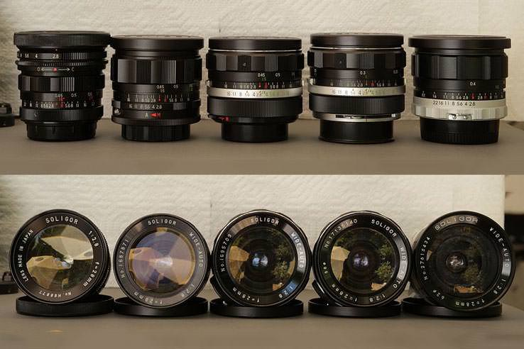
Different versions of the Soligor 2.8/28mm[visualopsins]
Similar to some other photographic equipment supplier, such as Vivitar, Soligor concentrated on the marketing, while it commissioned its lenses from Japan-based producers. The company collaborated with a number of different optics manufacturers, and some lenses, such as the popular 28mm f/2.8, are available in slightly altered versions from several manufacturers. The identity of the producer (Kawanon, Kino, Komine, Sun Optical, Tamron, or Tokina) can be derived from the serial number on the lens.

Serial number information
Producer identification
Serial Number Beginning | Lens Manufacturer
1 | Tokina
2 | Sun Optical
3 | Sun Optical
4 | Sun Optical
6 | Komine
7 | Sun Optical
9 | Kino
A | Komura
H37 | Kawanon
H4 | Kawanon
H5 | Komine
H6 | Komine
H7 | Tokina
T | Tamron
Y | Komura

The serial number on Soligor lenses makes it possible to derive the manufacturer of the lens, as well as the year of production. In particular, the first one to three characters identify the lens producer, the next digit the decade of production, followed by the year of production. For example, a lens whose serial number starts with "168" would have been produced by Tokina in 1968; and one with a serial number beginning with "H688" would have been manufactured by Komine in 1988.
Soligor lenses were produced for a number of different thread or bayonet mounts. Fixed mounts are available for all major camera brands, including Canon, Contax/Yashica, Konica AR, Minolta, Miranda, Nikon, Olympus, and Pentax. Optics that attach to the camera via a T-mount adapter (called "T2-mount") do not support automatic diaphragm coupling, so that the lens does not automatically stop down the aperture when a shot is taken. Instead, these lenses have two aperture rings. One is used to "preset" the desired aperture, while the other serves to actually stop the lens down. In use, one would select the shooting aperture (for example, f/8) on the aperture ring, and then open the lens up with the second ring to enable focusing in a brighter viewfinder. Once focus is achieved, one would turn the second ring fully back, and thereby stop down to the preset aperture for taking the picture.
Soligor's later T4-mount adapter made it possible to couple the diaphragm between camera and lens, so that the shooting aperture would automatically be transmitted to the lens and no presetting of the aperture would be required. Similarly, all Soligor lenses with M42 or fixed bayonet mounts support automatic diaphragm transmission between camera and lens.
Over time, Soligor released several distinctive lens series. The most prominent of these is the C/D line first released in the mid-1970s. While there is controversy whether the acronym stands for "computer designed" or "compact design", C/D lenses represented a premium line among the company's offer. However, even though the lens series contained some exceptional optics and very good performers, it did overall not achieve the consistently above-average quality that Vivitar, for example, attained with its "Series 1" lenses. Moreover, in the mid-1980s, the German subsidiary of AIC released several G/S-labeled lenses, which are part of the company's "Golden Series" and were manufactured by Sun Optical. These include the 2.5/24mm, 2.5/28mm, 2.5/135mm, 2.8/200mm, 4.5/300mm, 5.6/400mm, 3.5/35-140mm, 3.5/70-160mm, and the 3.5/70-222mm.
Soligor lenses were also sold under alternative brand names in different geographical markets. This alternative naming includes lenses branded as Aetna, Beroflex, Derek Gardner, Elicar, Flexar, Hanimar, Infotar, J.C. Penny, Mirage, Pallas, Porst, Prinzflex, Reflex, Super Carenar, and Weltblick. The only differences to the genuine optics are cosmetic and sometimes only involve the alteration of the inscription on the lens.
The main attraction of legacy manual focus lenses, like those from Soligor, is nowadays their rock-bottom pricing on the pre-owned market. Some physically very nice optics can be found for as low as $20 to $30. However, prices vary substantially and the price indication in the table below just provides a rough orientation. In any case, if you like to bargain-hunt and experiment in your photography with unusual gear, Soligor is a good place to start...

Headline Specifications of Soligor Lenses
Convert to METRIC
Wideangle |  | Camera  Mount  (type) | Focus  System  (mf/af) | Lens  Structure  (el/groups) | Close  Focus  (dist) | Filter  Type  (size) | Lens  Dimensions  (dia x len) | Lens  Weight  (net) | Ebay  Price  (USD) | Used  Offers  (ebay)
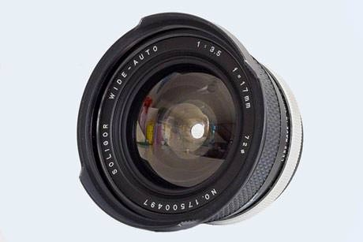 | Soligor Wide-Auto 17mm f/3.5 | M42; Fixed | MF | 11 / 8 | 0.24 yd | E72 | 2.2 x 3.1 in | 13.4 oz | 130-260 | check
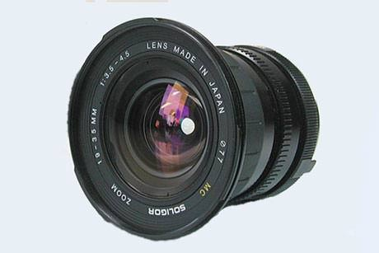 | Soligor AF 19-35mm f/3.5-4.5 MC | Fixed | AF | 13 / 11 | 0.55 yd | E77 | 3.2 x 2.8 in | 10.6 oz | 120-230 | check
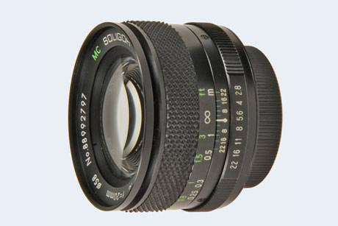 | Soligor C/D Wide-Auto 20mm f/2.8 MC | M42; Fixed | MF | 9 / 7 | 0.22 yd | E58 | 2.4 x 1.8 in | 8.1 oz | 160-330 | check
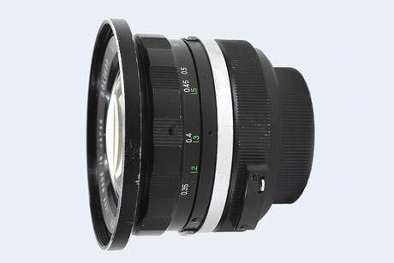 | Soligor Wide-Auto 21mm f/3.8 | T4; M42; Fixed | MF | 9 / 8 | 0.38 yd | E72 | 3.0 x 2.4 in | 9.2 oz | 80-170 | check
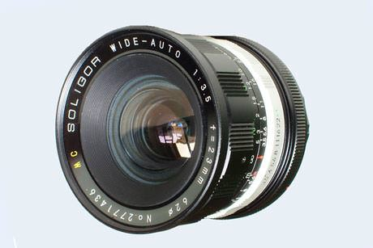 | Soligor Wide-Auto 23mm f/3.5 MC | M42; Fixed | MF | 8 / 6 | 0.33 yd | E62 | 2.6 x 2.2 in | 8.8 oz | 40-80 | check
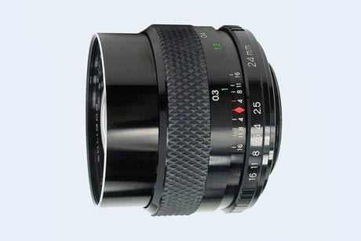 | Soligor Wide-Auto 24mm f/2.5 | IS; M42; Fixed | MF | 9 / 7 | 0.33 yd | E55 | 2.3 x 2.1 in | 9.2 oz | 70-130 | check
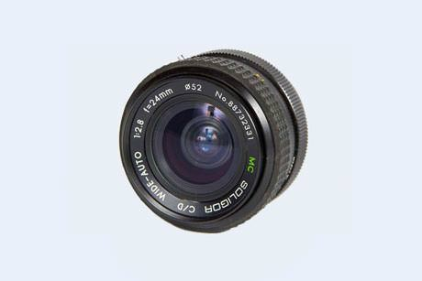 | Soligor C/D Wide-Auto 24mm f/2.8 MC | M42; Fixed | MF | 9 / 7 | 0.27 yd | E52 | 2.2 x 1.7 in | 8.5 oz | 60-120 | check
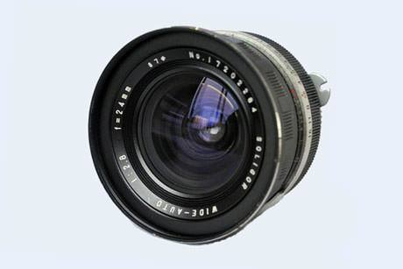 | Soligor Wide-Auto 24mm f/2.8 | T4 | MF | 8 / 7 | 0.49 yd | E67 | 2.8 x 2.7 in | 9.9 oz | 60-120 | check
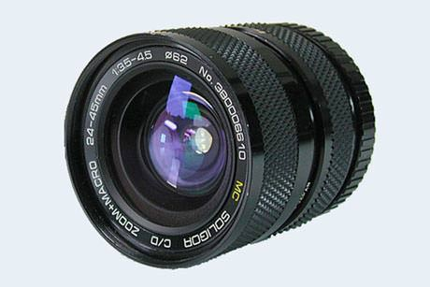 | Soligor C/D 24-45mm f/3.5-4.5 MC Macro | M42; Fixed | MF | 11 / 10 | 0.52 yd | E62 | 2.6 x 2.6 in | 14.1 oz | 80-170 | check
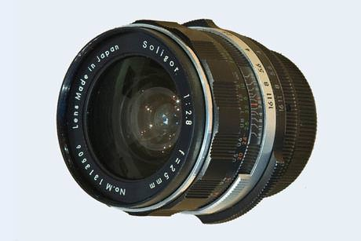 | Soligor 25mm f/2.8 | T2/T4 | MF | 8 / 6 | 0.27 yd | E52 | 2.3 x 2.2 in | 7.9 oz | 30-70 | check
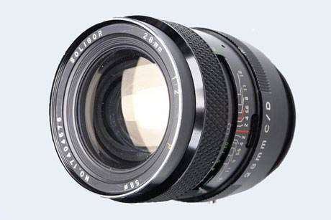 | Soligor C/D 28mm f/2.0 | M42; Fixed | MF | 8 / 7 | 0.24 yd | E58 | 2.4 x 2.5 in | 11.6 oz | 130-260 | check
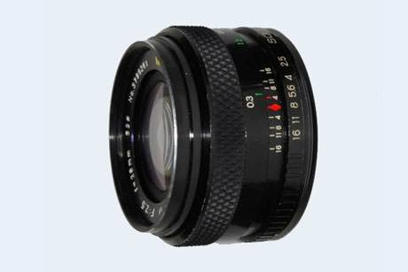 | Soligor 28mm f/2.5 | IS; M42; Fixed | MF | 8 / 7 | 0.33 yd | E52 | 2.4 x 1.6 in | 8.8 oz | 50-100 | check
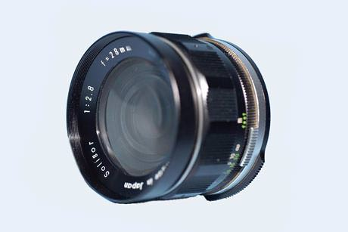 | Soligor 28mm f/2.8 (E58) | T2/T4 | MF | 7 / 6 | 0.31 yd | E58 | 2.4 x 2.2 in | 7.4 oz | 40-80 | check
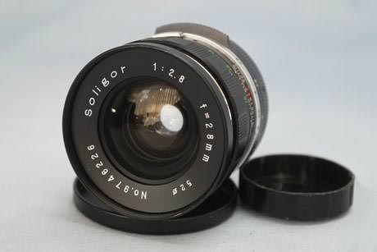 | Soligor 28mm f/2.8 MC (E52) | M42; Fixed | MF | 8 / 8 | 0.33 yd | E52 | 2.2 x 2.1 in | 7.4 oz | 40-80 | check
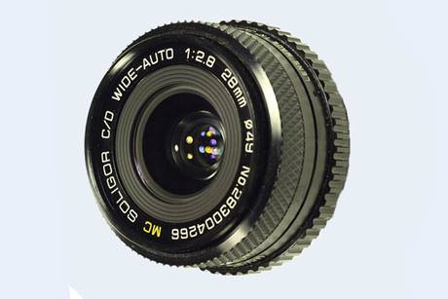 | Soligor C/D Wide-Auto 28mm f/2.8 MC | M42; Fixed | MF | 6 / 6 | 0.23 yd | E49 | 2.4 x 1.7 in | 7.2 oz | 50-100 | check
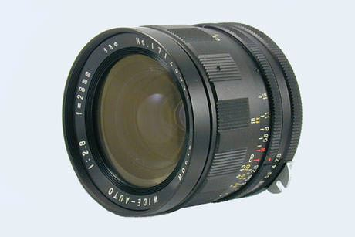 | Soligor Wide-Auto 28mm f/2.8 (E58) | Fixed | MF | 7 / 6 | 0.49 yd | E58 | 2.4 x 2.4 in | 9.3 oz | 40-80 | check
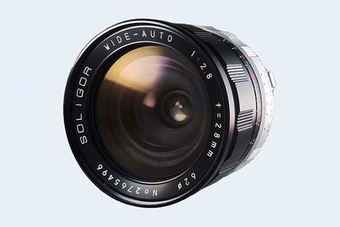 | Soligor Wide-Auto 28mm f/2.8 (E62) | Fixed | MF | 7 / 6 | 0.49 yd | E62 | 2.6 x 2.2 in | 10.6 oz | 40-80 | check
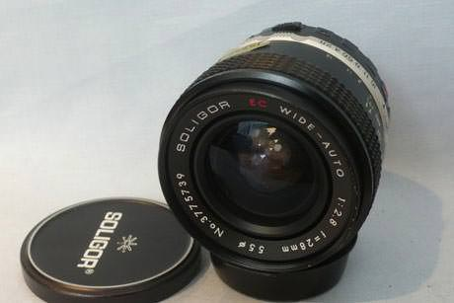 | Soligor Wide-Auto 28mm f/2.8 EC (E55) | Fixed | MF | 8 / 7 | 0.44 yd | E55 | 2.4 x 2.2 in | 7.4 oz | 40-80 | check
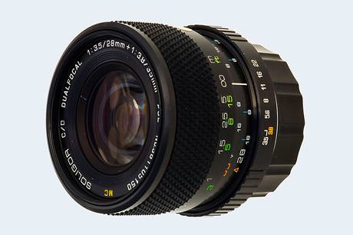 | Soligor C/D DualFocal 28mm/35mm f/3.5-3.8 MC | Fixed | MF | 9 / 9 | 0.44 yd | E52 | 2.3 x 2.0 in | 9.2 oz | 80-170 | check
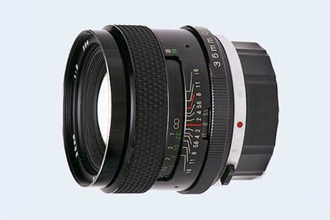 | Soligor C/D 35mm f/2.0 | M42; Fixed | MF | 8 / 7 | 0.32 yd | E58 | 2.5 x 2.0 in | 9.5 oz | 60-130 | check
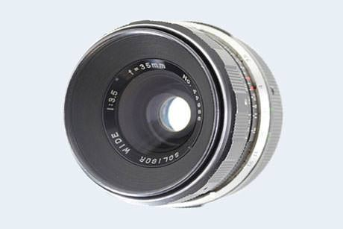 | Soligor Wide 35mm f/2.8 | T2 | MF | 6 / 5 | 0.55 yd | E46 | 2.0 x 1.8 in | 7.4 oz | 50-100 | check
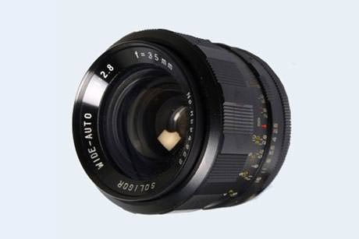 | Soligor Wide-Auto 35mm f/2.8 (E49) | M42; Fixed | MF | 6 / 5 | 0.66 yd | E49 | 2.1 x 2.0 in | 7.6 oz | 50-100 | check
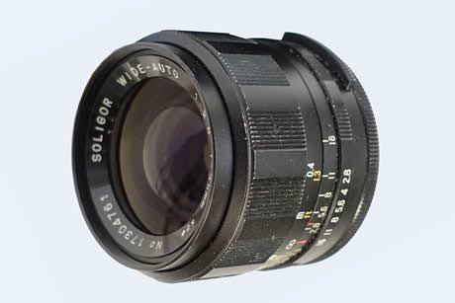 | Soligor Wide-Auto 35mm f/2.8 (E52) | M42 | MF | 6 / 5 | 0.33 yd | E52 | 2.2 x 2.0 in | 7.8 oz | 50-100 | check
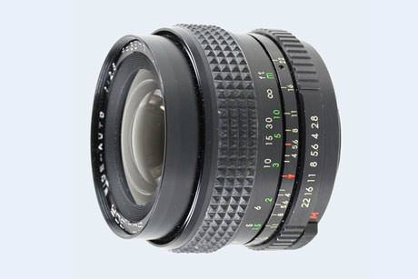 | Soligor Wide-Auto 35mm f/2.8 (E55) | Fixed | MF | 6 / 5 | 0.55 yd | E55 | 2.4 x 2.1 in | 8.1 oz | 50-100 | check
Standard |  | Camera  Mount  (type) | Focus  System  (mf/af) | Lens  Structure  (el/groups) | Close  Focus  (dist) | Filter  Type  (size) | Lens  Dimensions  (dia x len) | Lens  Weight  (net) | Ebay  Price  (USD) | Used  Offers  (ebay)
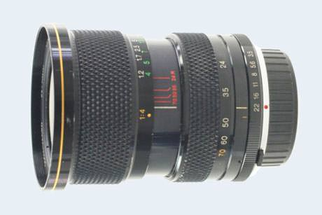 | Soligor C/D 24-70mm f/3.5-4.8 MC Macro | Fixed | MF | 14 / 10 | 1.31 yd | E67 | 2.8 x 3.6 in | 20.6 oz | 60-130 | check
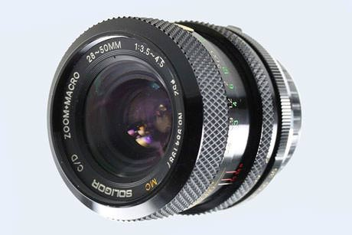 | Soligor C/D 28-50mm f/3.5-4.5 MC Macro | Fixed | MF | 10 / 10 | 0.98 yd | E52 | 2.4 x 2.0 in | 9.9 oz | 60-130 | check
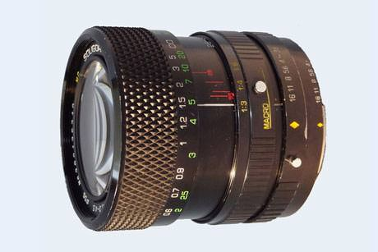 | Soligor C/D 28-55mm f/3.3-4.5 MC Macro | M42; Fixed | MF | 8 / 8 | 0.66 yd | E55 | 2.4 x 2.1 in | 10.9 oz | 60-130 | check
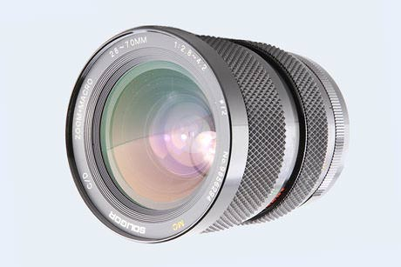 | Soligor C/D 28-70mm f/2.8-4.2 MC Macro | M42; Fixed | MF | 11 / 10 | 0.55 yd | E72 | 2.9 x 3.4 in | 16.9 oz | 60-130 | check
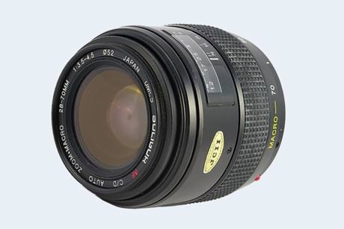 | Soligor AF C/D 28-70mm f/3.5-4.5 Macro | Fixed | AF | 10 / 9 | 0.77 yd | E52 | 2.8 x 2.8 in | 14.8 oz | 30-60 | check
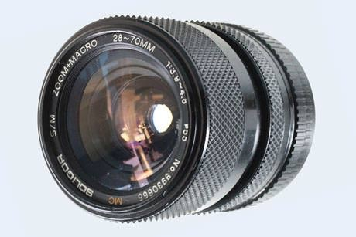 | Soligor S/M 28-70mm f/3.9-4.8 MC Macro | Fixed | MF | 9 / 9 | 0.87 yd | E55 | 2.6 x 2.6 in | 11.6 oz | 40-90 | check
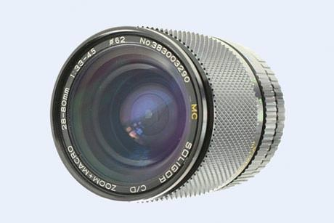 | Soligor C/D 28-80mm f/3.3-4.5 MC Macro | Fixed | MF | 10 / 9 | 1.09 yd | E62 | 2.6 x 3.3 in | 18.0 oz | 30-70 | check
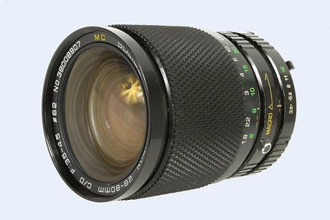 | Soligor C/D 28-80mm f/3.5-4.5 MC Macro | M42; Fixed | MF | 15 / 13 | 1.97 yd | E62 | 2.6 x 3.2 in | 17.6 oz | 30-70 | check
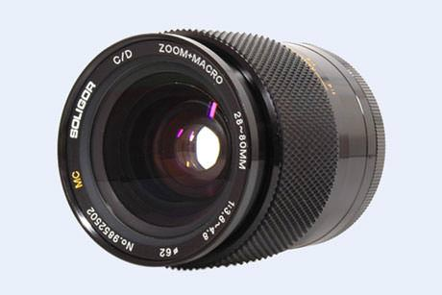 | Soligor C/D 28-80mm f/3.8-4.8 MC Macro | M42; Fixed | MF | 9 / 9 | 0.77 yd | E62 | 2.7 x 3.9 in | 14.6 oz | 100-190 | check
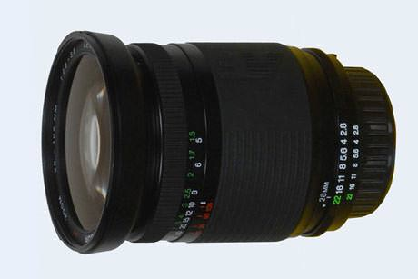 | Soligor AF 28-105mm f/2.8-3.8 MC | Fixed | AF | 15 / 13 | 1.64 yd | E72 | 3.0 x 3.5 in | 15.5 oz | 60-130 | check
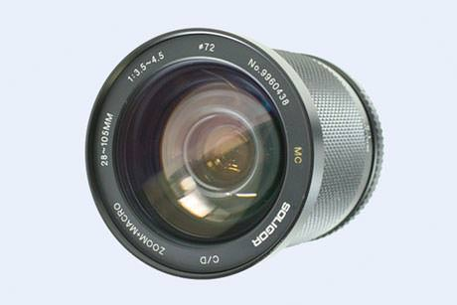 | Soligor C/D 28-105mm f/3.5-4.5 MC Macro | M42; Fixed | MF | 15 / 14 | 2.19 yd | E72 | 3.0 x 3.5 in | 16.2 oz | 40-90 | check
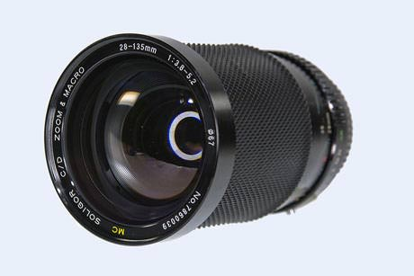 | Soligor C/D 28-135mm f/3.8-5.2 MC Macro | M42; Fixed | MF | 17 / 14 | 2.19 yd | E67 | 2.8 x 3.7 in | 19.0 oz | 50-100 | check
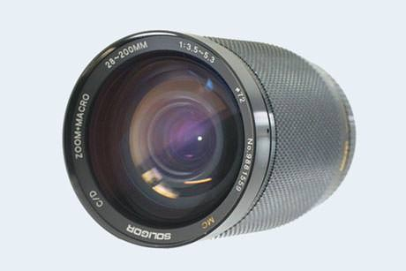 | Soligor C/D 28-200mm f/3.5-5.3 MC Macro | M42; Fixed | MF | 18 / 16 | 2.73 yd | E72 | 2.9 x 4.3 in | 22.9 oz | 30-70 | check
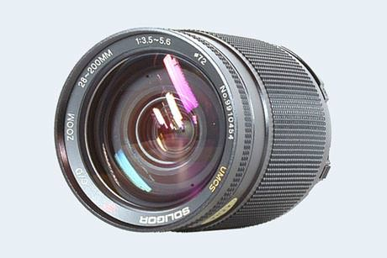 | Soligor AF C/D 28-200mm f/3.5-5.6 UMCS | Fixed | AF | 18 / 16 | 3.28 yd | E72 | 2.9 x 4.3 in | 30.0 oz | 50-100 | check
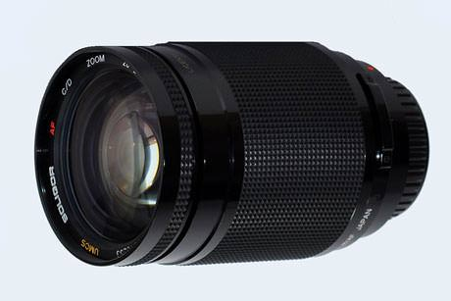 | Soligor C/D 28-200mm f/3.5-5.6 UMCS | M42; Fixed | MF | 18 / 16 | 2.73 yd | E72 | 2.9 x 4.1 in | 26.5 oz | 60-130 | check
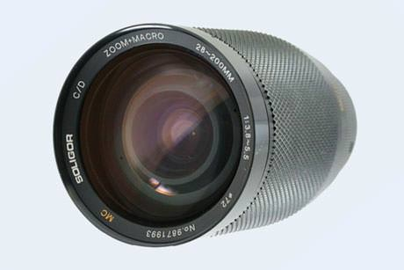 | Soligor C/D 28-200mm f/3.8-5.5 MC Macro | M42; Fixed | MF | 17 / 15 | 1.20 yd | E72 | 2.9 x 3.9 in | 19.4 oz | 30-70 | check
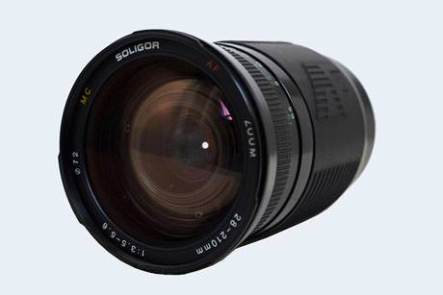 | Soligor AF C/D 28-210mm f/3.5-5.6 MC Macro | Fixed | AF | 14 / 12 | 2.08 yd | E72 | 3.0 x 4.2 in | 19.8 oz | 40-70 | check
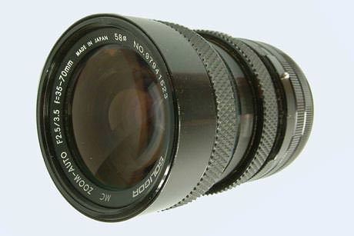 | Soligor Auto 35-70mm f/2.5-3.5 MC | M42; Fixed | MF | 10 / 9 | 0.55 yd | E58 | 2.5 x 3.3 in | 15.9 oz | 30-60 | check
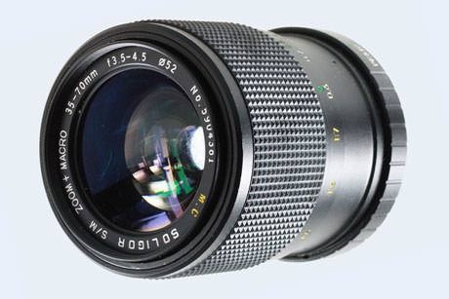 | Soligor S/M 35-70mm f/3.5-4.5 MC Macro | M42; Fixed | MF | 7 / 7 | 0.44 yd | E52 | 2.4 x 2.6 in | 12.3 oz | 30-60 | check
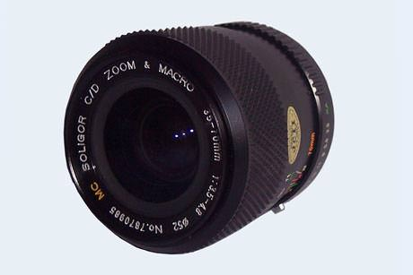 | Soligor C/D 35-70mm f/3.5-4.8 MC Macro | M42; Fixed | MF | 7 / 7 | 0.55 yd | E52 | 2.4 x 2.7 in | 12.3 oz | 30-60 | check
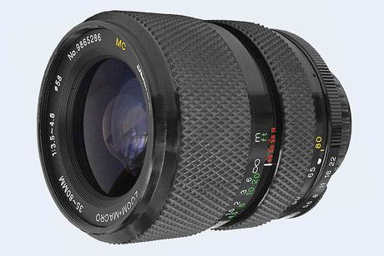 | Soligor C/D 35-80mm f/3.5-4.8 MC Macro | M42; Fixed | MF | 7 / 7 | 0.98 yd | E58 | 2.7 x 3.0 in | 12.2 oz | 30-60 | check
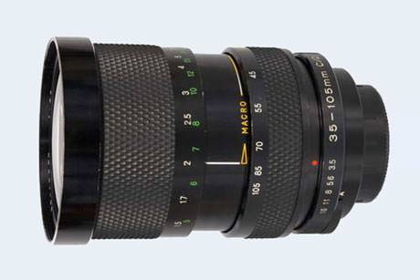 | Soligor C/D 35-105mm f/3.5 MC Macro | M42; Fixed | MF | 13 / 11 | 1.64 yd | E72 | 2.9 x 4.3 in | 24.7 oz | 50-100 | check
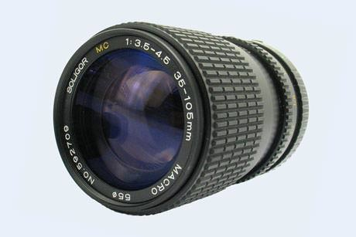 | Soligor 35-105mm f/3.5-4.5 MC Macro | M42; Fixed | MF | 13 / 11 | 1.64 yd | E55 | 2.4 x 3.3 in | 19.4 oz | 30-60 | check
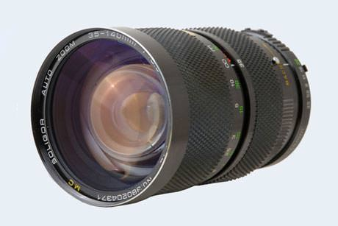 | Soligor Auto 35-140mm f/3.5 MC Macro | IS; M42; Fixed | MF | 13 / 10 | 1.64 yd | E72 | 2.9 x 4.9 in | 28.2 oz | 60-130 | check
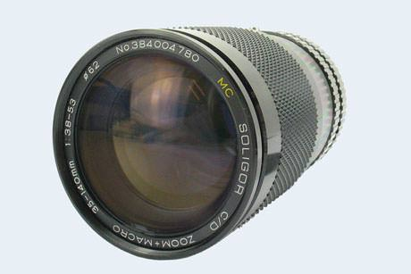 | Soligor C/D 35-140mm f/3.8-5.3 MC Macro | Fixed | MF | 13 / 11 | 2.19 yd | E62 | 2.5 x 3.8 in | 19.4 oz | 30-60 | check
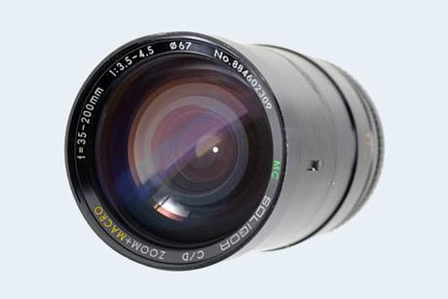 | Soligor C/D 35-200mm f/3.5-4.5 MC Macro | M42; Fixed | MF | 15 / 13 | 1.86 yd | E67 | 2.7 x 4.8 in | 22.9 oz | 50-100 | check
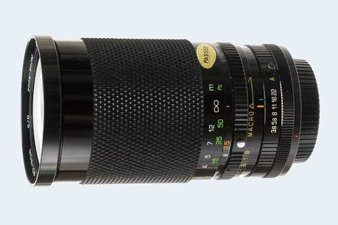 | Soligor C/D 35-200mm f/3.8-5.3 MC Macro | Fixed | MF | 15 / 13 | 2.73 yd | E67 | 2.7 x 5.0 in | 22.0 oz | 50-100
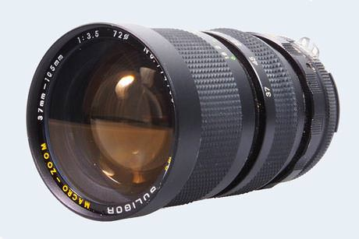 | Soligor 37-105mm f/3.5 MC Macro | M42; Fixed | MF | 13 / 10 | 1.97 yd | E72 | 2.9 x 5.0 in | 24.7 oz | 60-130
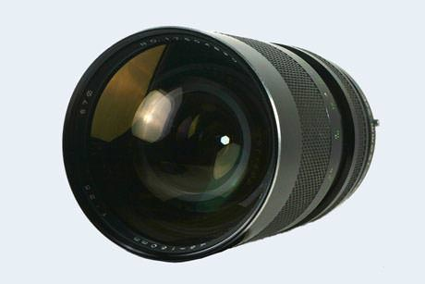 | Soligor C/D 45-150mm f/3.5 MC Macro | M42; Fixed | MF | 13 / 11 | 1.64 yd | E67 | 2.7 x 5.5 in | 31.7 oz | 60-110
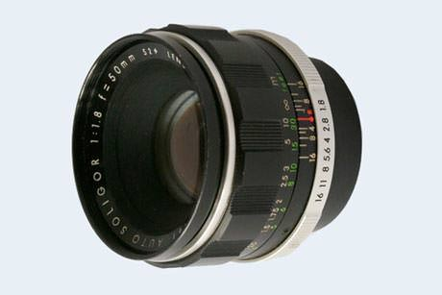 | Soligor Auto 50mm f/1.8 | M42 | MF | 6 / 5 | 0.49 yd | E52 | 2.2 x 1.7 in | 10.6 oz | 50-100
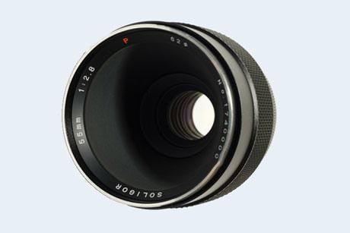 | Soligor C/D 55mm f/2.8 (Macro 1:2) | Fixed | MF | 5 / 4 | 0.07 yd | E62 | 2.6 x 3.1 in | 12.0 oz | 60-130
Tele-photo zooms |  | Camera  Mount  (type) | Focus  System  (mf/af) | Lens  Structure  (el/groups) | Close  Focus  (dist) | Filter  Type  (size) | Lens  Dimensions  (dia x len) | Lens  Weight  (net) | Ebay  Price  (USD) | Used  Offers  (ebay)
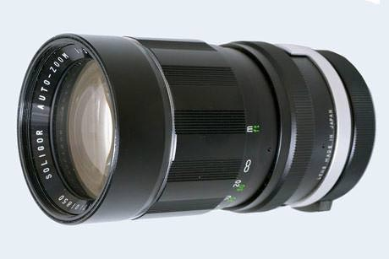 | Soligor Auto 55-135mm f/3.5 | T2; T4; M42; Fixed | MF | 13 / 9 | 1.64 yd | E62 | 2.7 x 5.0 in | 25.0 oz | 60-130
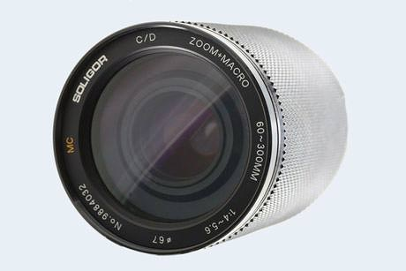 | Soligor C/D 60-300mm f/4.0-5.6 MC Macro | M42; Fixed | MF | 13 / 9 | 1.64 yd | E67 | 2.8 x 4.6 in | 20.4 oz | 60-110
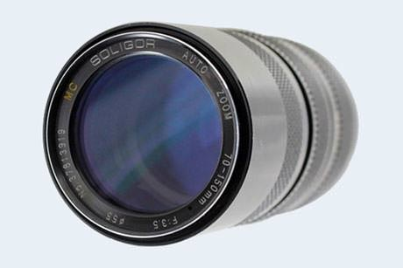 | Soligor Auto 70-150mm f/3.5 MC | Fixed | MF | 12 / 9 | 1.64 yd | E55 | 2.4 x 6.3 in | 17.8 oz | 40-90
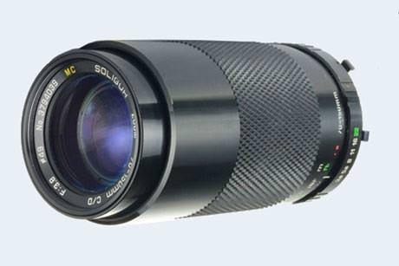 | Soligor C/D 70-150mm f/3.8 MC | Fixed | MF | 12 / 9 | 1.64 yd | E49 | 2.1 x 4.7 in | 17.4 oz | 30-60
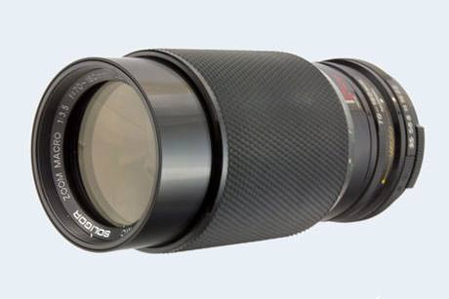 | Soligor C/D 70-160mm f/3.5 Macro | Fixed | MF | 12 / 9 | 1.64 yd | E55 | 2.6 x 5.6 in | 22.0 oz | 40-90
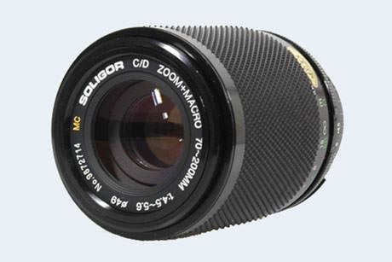 | Soligor C/D 70-200mm f/4.5-5.6 MC Macro | Fixed | MF | 12 / 10 | 1.09 yd | E49 | 2.6 x 3.1 in | 15.0 oz | 30-60
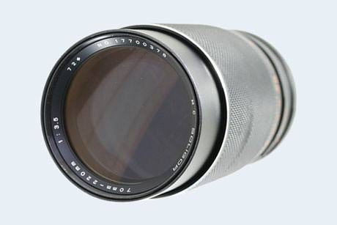 | Soligor 70-220mm f/3.5 MC | M42; Fixed | MF | 15 / 12 | 1.64 yd | E72 | 3.0 x 7.2 in | 48.3 oz | 60-130
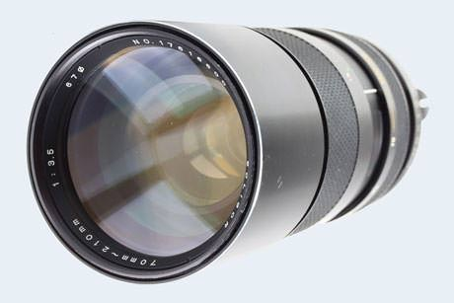 | Soligor C/D 70-210mm f/3.5 MC Macro | Fixed | MF | 12 / 9 | 1.64 yd | E67 | 2.9 x 6.5 in | 35.0 oz | 40-90
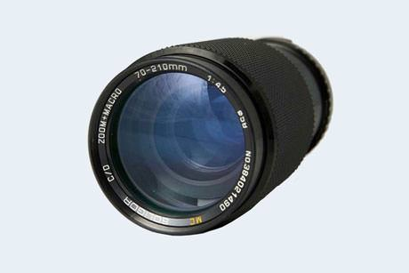 | Soligor C/D 70-210mm f/4.5 MC Macro | Fixed | MF | 12 / 9 | 2.19 yd | E58 | 2.6 x 5.2 in | 19.5 oz | 30-60
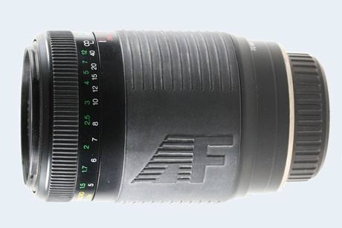 | Soligor AF 70-210mm f/4.5-5.6 MC Macro | Fixed | AF | 10 / 7 | 1.64 yd | E55 | 2.7 x 4.1 in | 14.8 oz | 40-70
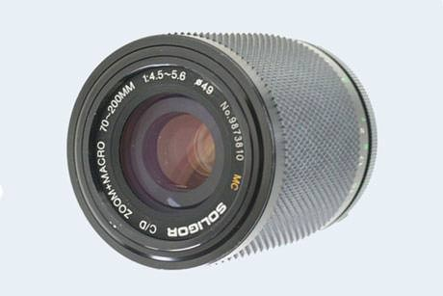 | Soligor C/D 70-210mm f/4.5-5.6 MC Macro | Fixed | MF | 12 / 9 | 1.09 yd | E49 | 2.9 x 6.9 in | 15.9 oz | 30-60
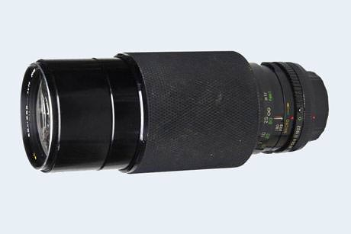 | Soligor C/D 70-222mm f/3.5 MC Macro | M42; Fixed | MF | 13 / 9 | 1.97 yd | E67 | 2.9 x 7.8 in | 42.3 oz | 30-60
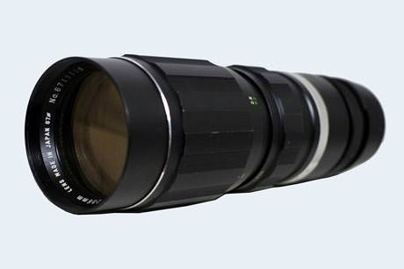 | Soligor Auto 70-235mm f/4.5 | M42; Fixed | MF | 8 / 8 | 2.73 yd | E67 | 2.8 x 10.4 in | 28.2 oz | 30-70
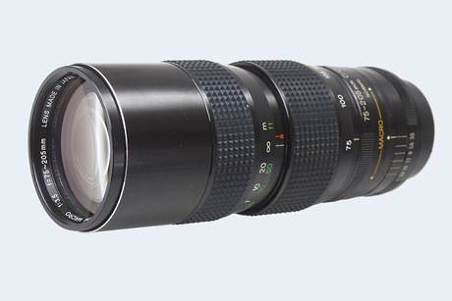 | Soligor C/D 75-205mm f/3.5 | M42; Fixed | MF | 13 / 9 | 2.19 yd | E62 | 2.6 x 6.4 in | 38.8 oz | 30-70
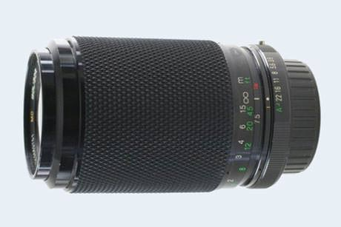 | Soligor C/D 75-205mm f/3.8-4.8 MC Macro | M42; Fixed | MF | 12 / 9 | 1.64 yd | E52 | 2.6 x 4.1 in | 18.0 oz | 30-50
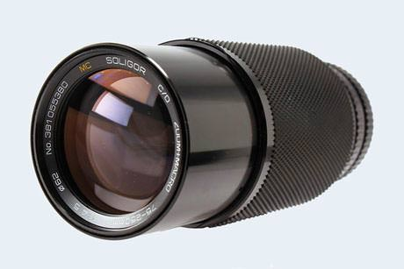 | Soligor C/D 75-250mm f/4.5 MC Macro | Fixed | MF | 13 / 10 | 2.73 yd | E62 | 2.6 x 6.9 in | 22.9 oz | 30-60
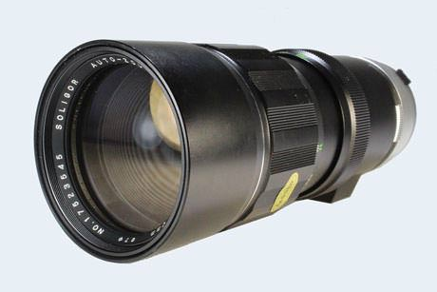 | Soligor Auto 75-260mm f/4.5 | T4; M42; Fixed | MF | 13 / 10 | 1.64 yd | E67 | 2.8 x 7.7 in | 40.9 oz | 30-70
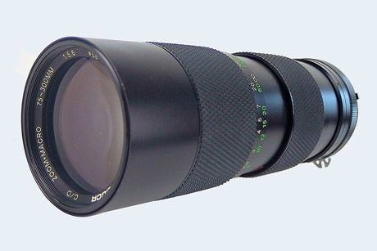 | Soligor C/D 75-300mm f/5.6 MC Macro | M42; Fixed | MF | 13 / 9 | 1.42 yd | E58 | 2.6 x 6.7 in | 26.1 oz | 40-90
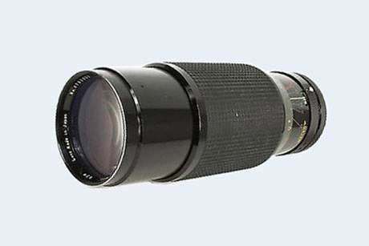 | Soligor C/D 78-210mm f/3.5 MC Macro | Fixed | MF | 12 / 8 | 2.19 yd | E62 | 3.0 x 7.4 in | 32.2 oz | 60-120
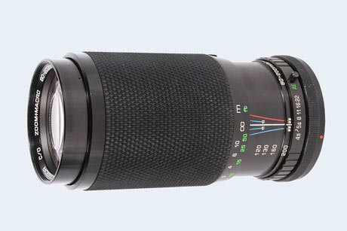 | Soligor C/D 80-200mm f/4.5 MC Macro | Fixed | MF | 13 / 9 | 2.19 yd | E55 | 2.5 x 4.8 in | 18.4 oz | 30-50
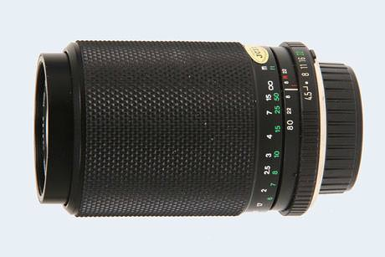 | Soligor C/D 80-200mm f/4.5-5.6 MC Macro | Fixed | MF | 10 / 8 | 2.19 yd | E55 | 2.5 x 5.0 in | 18.1 oz | 30-50
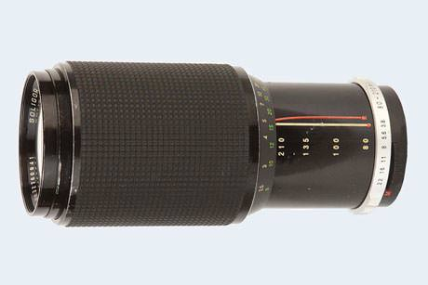 | Soligor Auto 80-210mm f/3.8 | M42; Fixed | MF | 14 / 9 | 2.19 yd | E62 | 2.8 x 7.1 in | 33.9 oz | 30-70
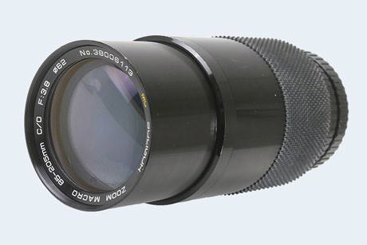 | Soligor C/D 85-205mm f/3.8 MC Macro | M42; Fixed | MF | 12 / 9 | 2.73 yd | E62 | 2.7 x 5.8 in | 30.0 oz | 30-70
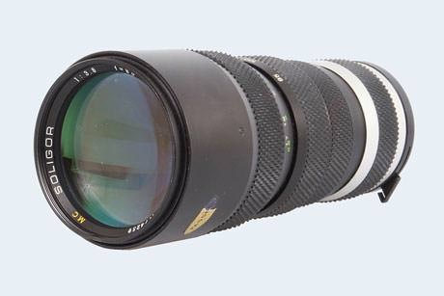 | Soligor 85-210mm f/3.8 MC | M42; Fixed | MF | 12 / 9 | 1.86 yd | E62 | 2.6 x 6.3 in | 29.6 oz | 30-70
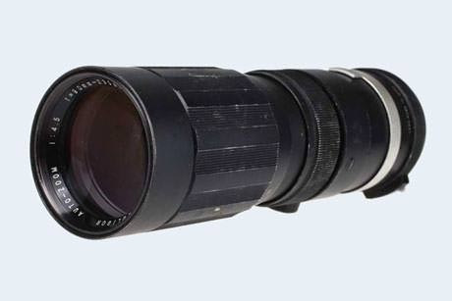 | Soligor Auto 90-230mm f/4.5 | T2, T4, M42, Fixed | MF | 11 / 7 | 2.73 yd | E58 | 2.4 x 8.1 in | 18.7 oz | 30-70
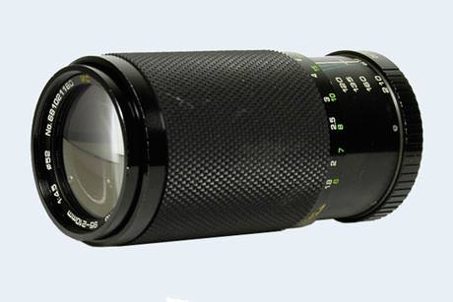 | Soligor C/D 95-210mm f/4.5 MC Macro | M42; Fixed | MF | 12 / 9 | 1.97 yd | E52 | 2.5 x 5.0 in | 18.2 oz | 30-70
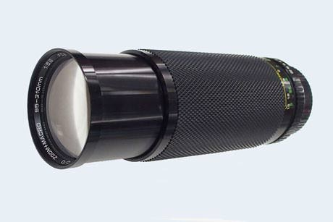 | Soligor C/D 95-310mm f/5.6 MC Macro | M42; Fixed | MF | 14 / 9 | 1.64 yd | E58 | 3.7 x 6.7 in | 22.4 oz | 30-60
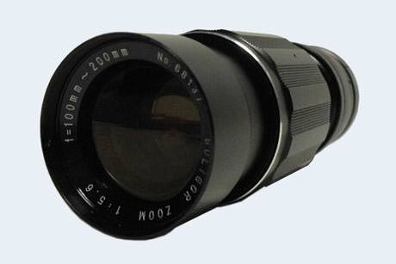 | Soligor 100-200mm f/5.6 | T2 | MF | 7 / 5 | 3.28 yd | E55 | 2.4 x 7.5 in | 17.6 oz | 30-50
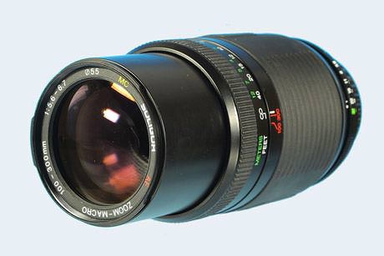 | Soligor AF 100-300mm f/5.6-6.7 MC | Fixed | AF | 10 / 7 | 1.64 yd | E55 | 2.4 x 6.8 in | 24.7 oz | 70-130
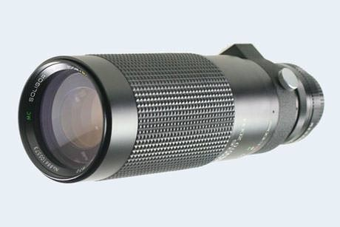 | Soligor C/D 100-500mm f/5.6-7.5 | Fixed | MF | 15 / 9 | 1.97 yd | E72 | 3.0 x 10.5 in | 52.9 oz | 130-260
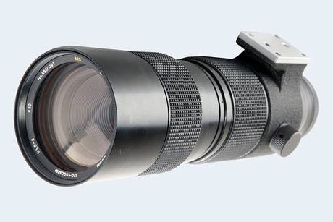 | Soligor 120-600mm f/5.6-8 | M42, Fixed | MF | 15 / 11 | 4.37 yd | E82 | 3.5 x 11.4 in | 77.6 oz | 160-330
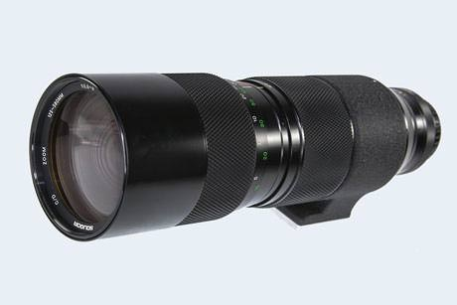 | Soligor C/D 125-580mm f/5.6-8 | Fixed | MF | 15 / 11 | 4.37 yd | E82 | 3.3 x 13.4 in | 74.1 oz | 200-400
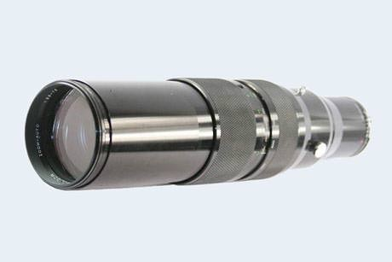 | Soligor Auto 130-650mm f/5.6-7.5 | Fixed | MF | 15 / 9 | 4.37 yd | E86 | 3.5 x 14.6 in | 74.1 oz | 160-330
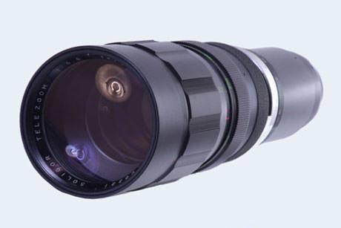 | Soligor 180-400mm f/5.6 | T2 | MF | 11 / 7 | 4.37 yd | E77 | 3.2 x 14.8 in | 63.5 oz | 160-330
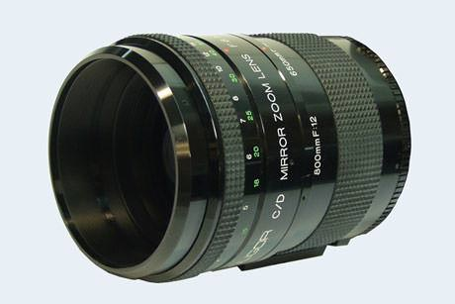 | Soligor C/D 500-800mm f/8-12 Mirror | Fixed | MF | 6 / 6 | 4.37 yd | rear | 3.9 x 5.3 in | 36.5 oz | 200-400
Tele-photo primes |  | Camera  Mount  (type) | Focus  System  (mf/af) | Lens  Structure  (el/groups) | Close  Focus  (dist) | Filter  Type  (size) | Lens  Dimensions  (dia x len) | Lens  Weight  (net) | Ebay  Price  (USD) | Used  Offers  (ebay)
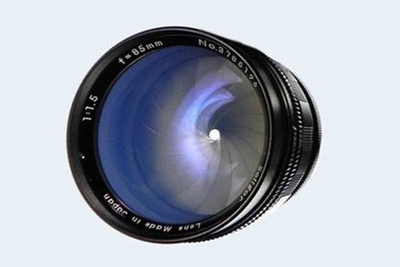 | Soligor 85mm f/1.5 | T2 | MF | 7 / 5 | 0.98 yd | E62 | 2.5 x 3.7 in | 18.0 oz | 200-400
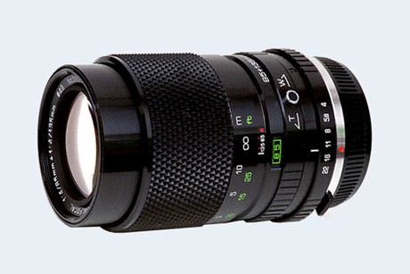 | Soligor Dual Focus 85mm/135mm f/4 | Fixed | MF | 9 / 6 | 1.97 yd | E49 | 2.2 x 4.0 in | 13.4 oz | 30-60
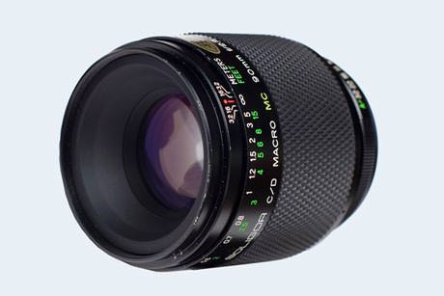 | Soligor C/D 90mm f/2.5 MC Macro (1:1) | Fixed | MF | 6 / 5 | 0.38 yd | E62 | 2.6 x 3.3 in | 19.6 oz | 130-260
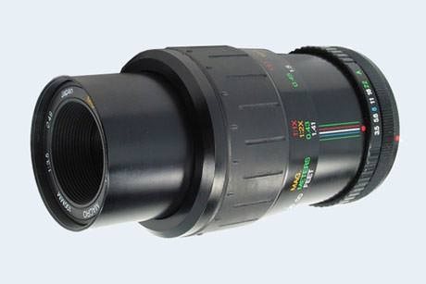 | Soligor AF 100mm f/3.5 Macro (1:2) | Fixed | AF | 5 / 4 | 0.47 yd | E49 | 2.4 x 2.8 in | 7.9 oz | 60-130
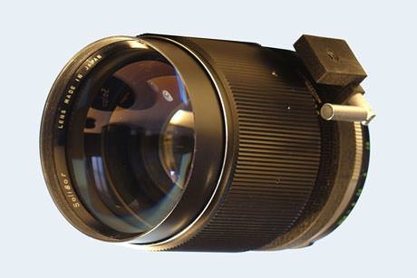 | Soligor 135mm f/1.5 | T2 | MF | 6 / 4 | 1.31 yd | E98 | 4.1 x 6.0 in | 95.2 oz | $$$
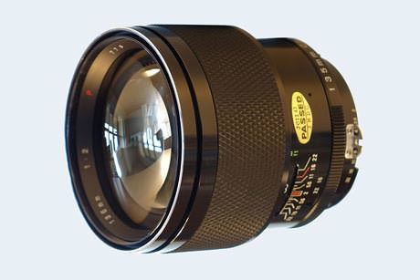 | Soligor C/D 135mm f/2.0 | M42; Fixed | MF | 6 / 5 | 1.97 yd | E77 | 3.2 x 3.5 in | 26.8 oz | 200-400
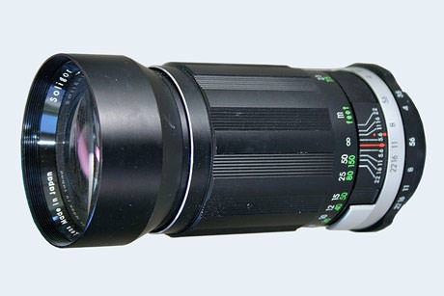 | Soligor 180mm f/3.5 | T2 | MF | 4 / 4 | 2.52 yd | E58 | 2.4 x 4.7 in | 17.5 oz | 40-90
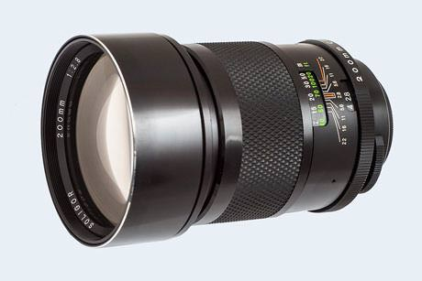 | Soligor C/D 200mm f/2.8 | M42; Fixed | MF | 6 / 4 | 2.41 yd | E77 | 3.1 x 5.0 in | 26.8 oz | 50-100
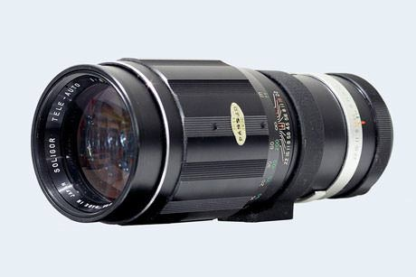 | Soligor Tele-Auto 250mm f/4.5 | M42; Fixed | MF | 4 / 4 | 4.92 yd | E62 | 2.6 x 7.7 in | 24.3 oz | 30-60
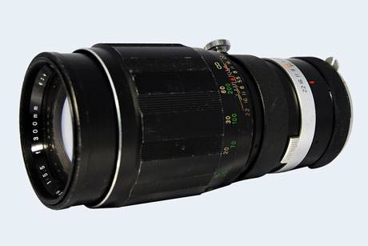 | Soligor 300mm f/5.5 | T4; M42; Fixed | MF | 5 / 4 | 6.56 yd | E62 | 2.7 x 6.5 in | 30.7 oz | 60-110
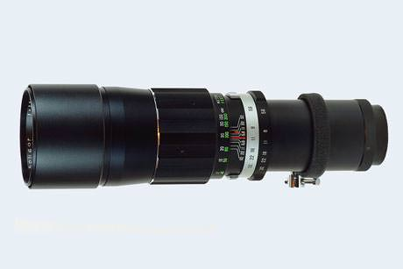 | Soligor 350mm f/5.6 | T2; T4 | MF | 4 / 2 | 5.47 yd | E67 | 2.8 x 9.8 in | 31.6 oz | 50-100
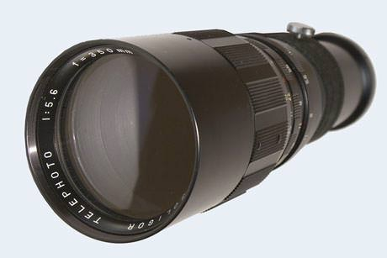 | Soligor Telephoto 350mm f/5.6 | T2; T4 | MF | 4 / 2 | 8.75 yd | E72 | 3.0 x 9.6 in | 32.9 oz | 50-100
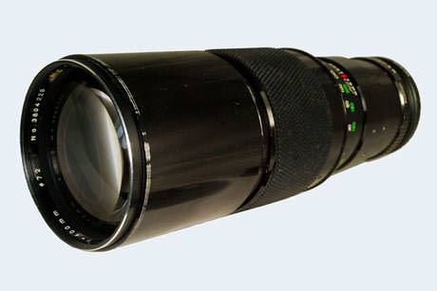 | Soligor 400mm f/5.6 | M42; Fixed | MF | 4 / 4 | 5.47 yd | E72 | 3.1 x 9.4 in | 35.3 oz | 50-100
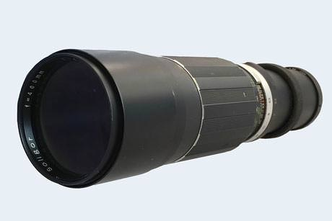 | Soligor 400mm f/6.3 | T2 | MF | 4 / 4 | 7.11 yd | E67 | 3.1 x 12.2 in | 35.8 oz | 50-100
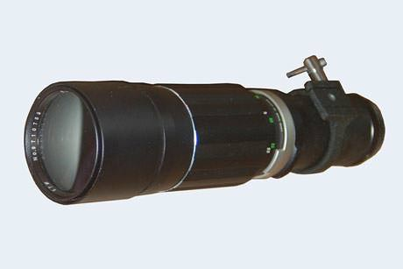 | Soligor Tele 400mm f/6.3 | M42; Fixed | MF | 4 / 3 | 7.66 yd | E67 | 3.1 x 11.8 in | 35.8 oz | 50-100
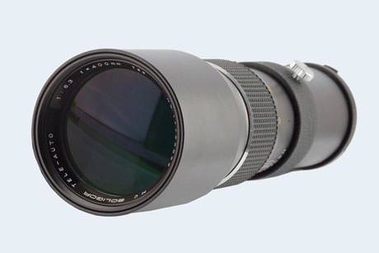 | Soligor Tele-Auto 400mm f/6.3 MC | M42; Fixed | MF | 4 / 3 | 8.31 yd | E72 | 3.2 x 11.8 in | 35.6 oz | 50-100
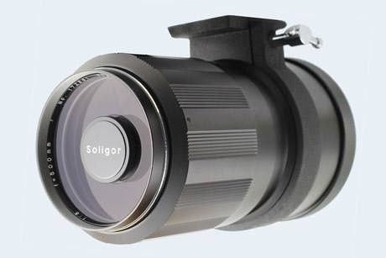 | Soligor 500mm f/8 Mirror | T2 | MF | 4 / 4 | 10.94 yd | E77 | 3.3 x 4.7 in | 17.6 oz | 60-130
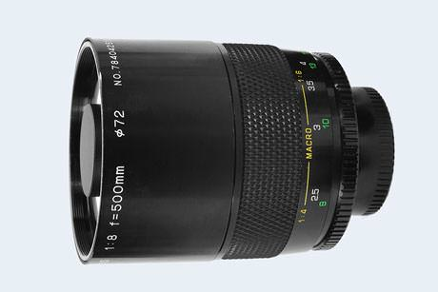 | Soligor C/D 500mm f/8 MC Mirror | M42; Fixed | MF | 5 / 4 | 2.73 yd | E72 | 3.1 x 4.2 in | 12.6 oz | 60-130
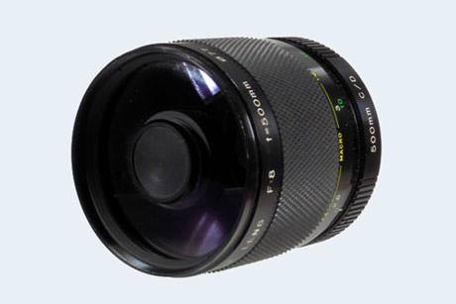 | Soligor C/D 500mm f/8 Mirror | T2 | MF | 5 / 4 | 2.73 yd | E77 | 3.1 x 3.3 in | 18.8 oz | 60-130
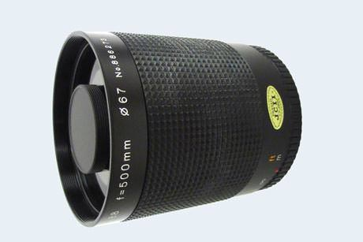 | Soligor 500mm f/8.8 Mirror | T2 | MF | 8 / 5 | 2.73 yd | E67 | 2.8 x 3.5 in | 12.3 oz | 60-130
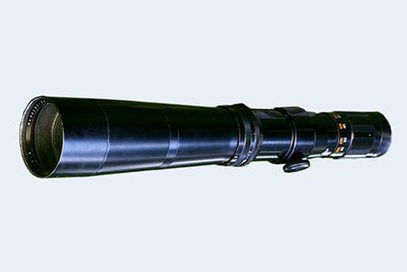 | Soligor 600mm f/8 | T2 | MF | 2 / 1 | 14.22 yd | E87 | 3.5 x 23.6 in | 158.7 oz | 130-260
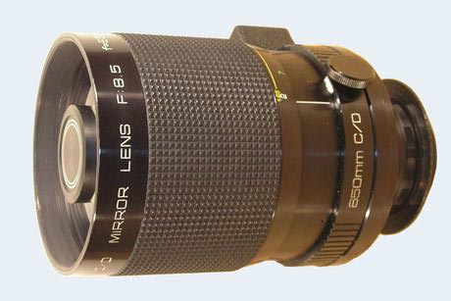 | Soligor C/D 650mm f/8.5 Mirror | T2 | MF | 7 / 6 | 2.19 yd | E88 | 3.7 x 4.6 in | 31.9 oz | 130-260
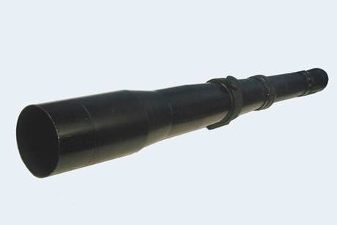 | Soligor 800mm f/8 | T2 | MF | 2 / 1 | 27.34 yd | no | 3.5 x 31.5 in | 211.6 oz | $$$

Further Reading
For detailed Soligor lens reviews, there are unfortunately very few in-depth assessments available on the web. In the supertele category, you can find additional information on the 400mm f/5.6 and the different versions of the 400mm f/6.3 on this site. These lenses provide a solid entry into long telephoto photography at bargain prices. Comparable offers are also available from other third party lens suppliers, such as Tamron or Vivitar. If you are looking for a marked step-up in optical quality in legacy manual focus lenses and are willing to spend a little more, you might also want to check out the Leica R-lens catalog, which contains some truly exceptional optics that can be adapted to and used with a variety of camera mounts.

