Tamron Adaptall Lenses

This information taken from https://www.apotelyt.com/

This is provided to the Orphan Camera users that use these lenses.

In the mid-1970s, Tamron launched a new line of interchangeable mount third party lenses that it appropriately named Adaptall. The universal lens bodies connected via a bayonet to one side of an Adaptall adapter, whose other side had a camera-specific fitting. The connection enabled auto diaphragm and full aperture metering. This system was easier to handle and more solid than the company's earlier Adapt-A-Matic mount.

Like other universal fittings, Tamron's Adaptall made it possible for professional and enthusiast photographers with cameras from two or more manufacturers to use their Tamron lenses on different bodies with the help of inexpensive adapters. Also, switching camera brands became much easier and cheaper, since with the Tamron system only the Adaptall-mounts and not the entire bag of lenses had to be replaced. Moreover, the system provided substantial benefits for Tamron's retail partners, who did not have to stock every individual lens in different mounts, but only had to keep one copy of the expensive lens and an assortment of cheap mount adapters in store. On the downside, the mount adapters as individual pieces of solid metal had their own manufacturing tolerances that could potentially lead to a slight de-centering of the lens with adverse effects on imaging performance.

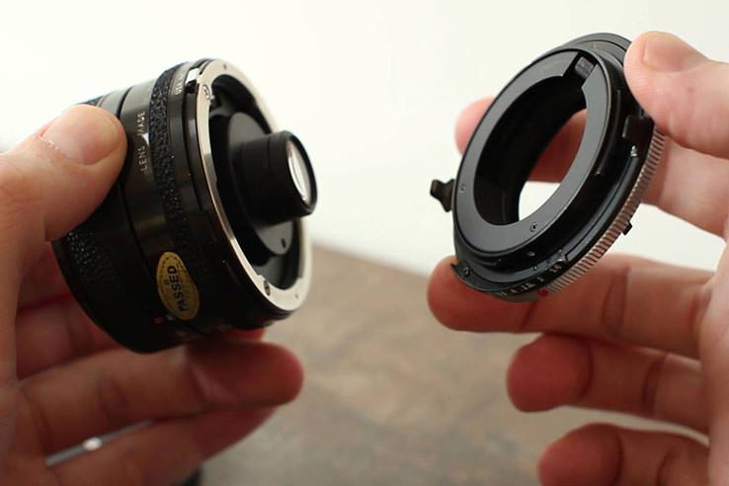

The Tamron Adaptall mount
Adaptall Custom adapters were available for virtually all camera mounts of the 1970s and 1980s, including Canon FD, Minolta MD, Konica AR, Contax/Yashica, Olympus OM, Nikon AI, M42, Pentax K, Fujica FT, Topcon RE, Mamiya SX, Rollei, and Praktica. There are two versions of the Adaptall mount. The original adapter, as introduced in 1973, and a slightly modified Adaptall-2, which was marketed from 1979. Both versions have the same physical lens fitting, but only Adaptall-2 mounts transmit the lenses' maximum aperture to the camera. For some mounts, the additional functionality of Adaptall-2 makes no difference, so that Adaptall and Adaptall-2 units can be used interchangeably.

However, some complex lens to camera fittings, notably Canon FD, Minolta MD, and Konica AR, require information on the maximum aperture of the lens in order to control the aperture correctly. With the original Adaptall mount, owners of "complex mount" cameras needed to use an adapter specific to the maximum aperture of the lens and, thus, had to buy several adapters if they wanted to use Tamron lenses with differing maximum openings (e.g. f/2.8, f/3.5, f/3.8). For a third group of camera systems, the introduction of Adaptall-2 brought some other benefits. For Contax/Yashica, there was no longer a need to set the maximum aperture, and the latter was also displayed in the viewfinder. For Olympus OM, the new adapter gained a depth-of-field preview lever.

Timeline of Tamron interchangeable mounts
Mount | Launch Year
T | 1957
Adapt-A-Matic | 1968
Adaptall | 1973
Adaptall-2 | 1979

Taiseh Optical (which became Tamron in 1970) entered the market for camera lenses in 1957, when it introduced the T-mount. The latter was named after the first letter of the company's name, and permitted any of the company's lenses to be coupled to virtually every 35mm camera via an adapter. Subsequent universal mounts from Tamron – Adapt-A-Matic, Adaptall, and Adaptall-2 – improved handling convenience and aperture coupling.

Most of the camera mounts for which Adaptall adapters existed are no longer used in the era of digital photography. The exceptions are the Nikon F and Pentax K bayonets. Yet, Adaptall lenses can still be used on newer camera systems through a combination of adapters, for example lens plus Adaptall-M42-mount plus M42-EOS-adapter. Moreover, some third party supplier have spotted the opportunity and provide adapters that directly link Tamron Adaptall lenses to digital camera mounts (click here for the respective offer of Fotodiox on amazon). However, these adapter-combinations or adapters-to-digital-mounts do not offer aperture coupling, so that the lenses have to be operated in stop-down mode.

The introduction of the Adaptall-2 mount coincided with a cosmetic update of Tamron's existing lenses, as well as the introduction of its new premium SP-line. These "Super Performance" lenses aimed to provide photographers with imaging quality similar to lenses from original equipment manufacturers, but at reduced costs. Tamron's marketing strategy was, thus, similar to the one pursued by Vivitar with its Series 1 lenses. Indeed, the SP-lenses quickly gained a reputation for consistent above-average performance and cemented Tamron's position as a third party supplier.

Within the SP-line, several lenses featured low dispersion optical elements and carried the corresponding LD acronym in the lens name. These LD-lenses provided particularly good imaging quality and competed against the top-level lenses from Canon, Nikon, Minolta and others in the market for professional photo gear. These optics continue to be highly regarded and command relatively high prices in the used market.
The table below lists the main specifications of all the Adaptall and Adaptall-2 lenses that were released. It should be noted that Tamron specified the measurements of the Adaptall and Adaptall-2 lenses without any mount adapter, so that the lens in the operational state will be a bit longer and heavier.

Tamron discontinued the last lenses in its Adaptall-2 manual focus line in 2006, giving way to fixed mount autofocus lenses.
Headline Specifications of Tamron Adaptall Lenses
Convert to METRIC
Wideangle |  | Mount  Type  (AD/AD2) | Lens  ID  (#) | Production  Period  (years) | Filter  Type  (size) | Lens  Dimensions  (dia x len) | Lens  Weight  (net) | Ebay  Price  (USD) | Used  Offers  (ebay)
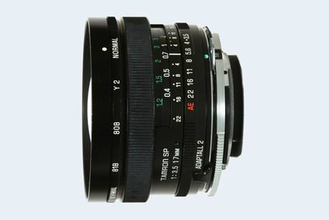 | Tamron SP 17mm f/3.5 | Ad2 | 51B | 1979-1984 | no | 2.8 x 1.7 in | 9.5 oz | 100-250
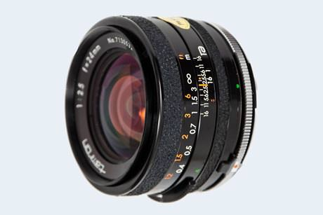 | Tamron 24mm f/2.5 | Ad1 | CW-24 | 1976-1979 | 55 | 2.6 x 1.5 in | 7.8 oz | 20-80
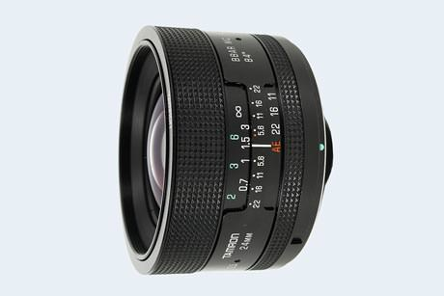 | Tamron 24mm f/2.5 | Ad2 | 01B | 1979-1987 | 55 | 2.6 x 1.5 in | 8.1 oz | 30-90
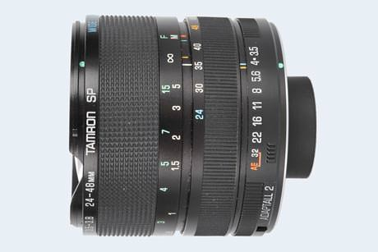 | Tamron SP 24-48mm f/3.5-3.8 | Ad2 | 13A | 1980-1987 | no | 2.6 x 2.4 in | 12.2 oz | 50-150
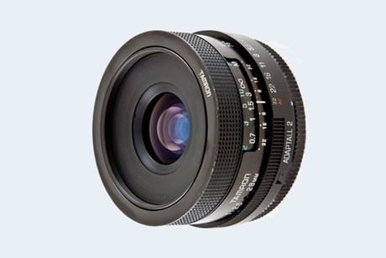 | Tamron 28mm f/2.5 | Ad2 | 02B | 1979-1992 | 49 | 2.6 x 1.3 in | 6.3 oz | 30-60
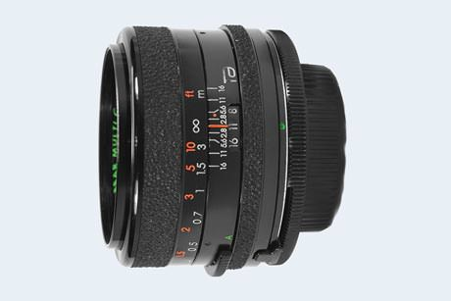 | Tamron 28mm f/2.8 | Ad1 | CW-28 | 1976-1979 | 52 | 2.6 x 1.7 in | 8.5 oz | 10-40
Standard |  | Mount  Type  (AD/AD2) | Lens  ID  (#) | Production  Period  (years) | Filter  Type  (size) | Lens  Dimensions  (dia x len) | Lens  Weight  (net) | Ebay  Price  (USD) | Used  Offers  (ebay)
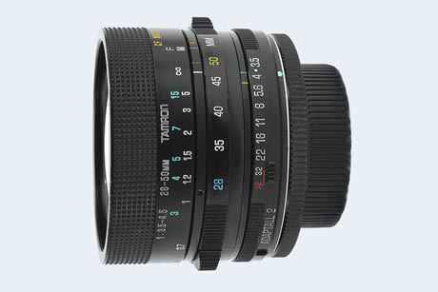 | Tamron 28-50mm f/3.5-4.5 | Ad2 | 07A | 1980-1982 | 58 | 2.6 x 1.8 in | 10.5 oz | 10-40
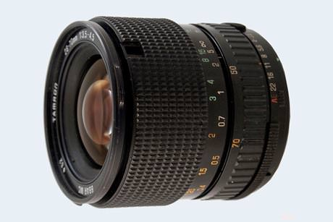 | Tamron 28-70mm f/3.5-4.5 | Ad2 | 44A | 1986-1988 | 62 | 2.7 x 2.8 in | 12.7 oz | 20-50
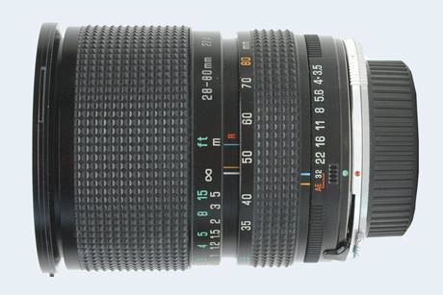 | Tamron SP 28-80mm f/3.5-4.2 | Ad2 | 27A | 1983-1987 | 67 | 2.8 x 3.2 in | 16.9 oz | 20-50
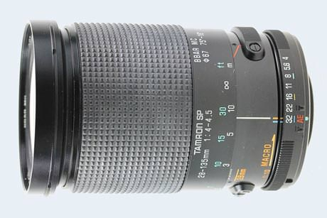 | Tamron SP 28-135mm f/4-4.5 | Ad2 | 28A | 1983-1988 | 67 | 2.8 x 4.2 in | 25.0 oz | 30-60
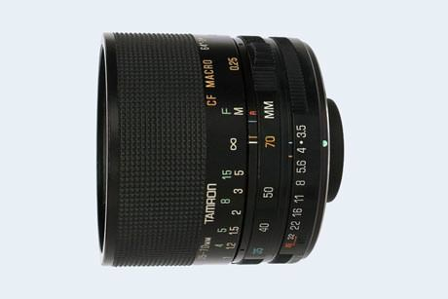 | Tamron 35-70mm f/3.5 | Ad2 | 17A | 1982-1987 | 58 | 2.6 x 2.0 in | 11.6 oz | 20-40
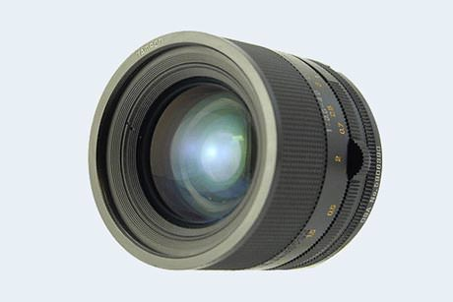 | Tamron 35-70mm f/3.5-4.5 | Ad2 | 09A | 1980-1983 | 58 | 2.6 x 2.2 in | 11.4 oz | 20-40
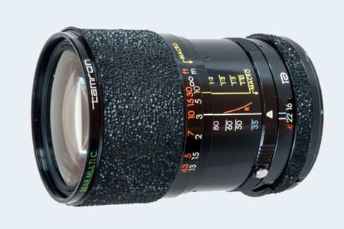 | Tamron 35-80mm f/2.8-3.5 | Ad1 | QZ-35M | 1978-1980 | 62 | 2.6 x 3.2 in | 18.3 oz | 20-80
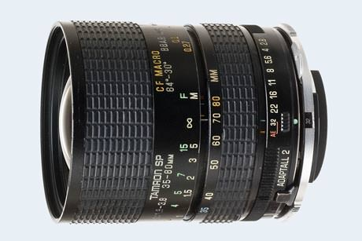 | Tamron SP 35-80mm f/2.8-3.8 | Ad2 | 01A | 1979-1985 | 62 | 2.6 x 2.8 in | 13.6 oz | 50-250
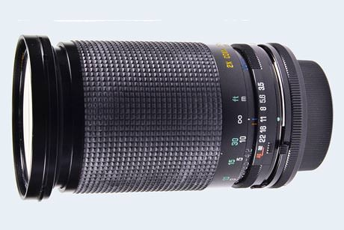 | Tamron 35-135mm f/3.5-4.2 | Ad2 | 22A | 1982-1985 | 67 | 2.8 x 4.1 in | 22.0 oz | 20-60
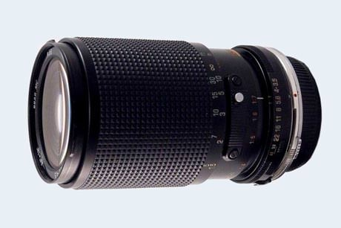 | Tamron 35-135mm f/3.5-4.5 | Ad2 | 40A | 1985-1996 | 58 | 2.6 x 3.8 in | 19.3 oz | 20-60
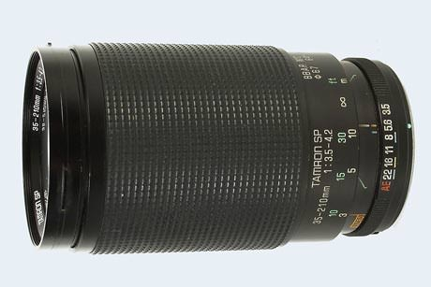 | Tamron SP 35-210mm f/3.5-4.2 | Ad2 | 26A | 1983-1987 | 67 | 2.9 x 4.8 in | 30.9 oz | 20-80
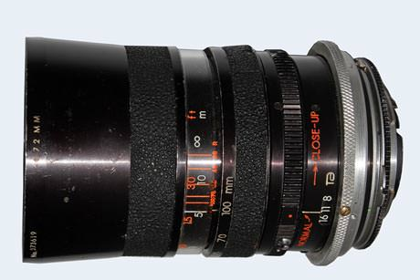 | Tamron 38-100mm f/3.5 (SZ-38) | Ad1 | SZ-38 | 1973-1976 | 72 | 3.0 x 4.9 in | 26.5 oz | 20-50
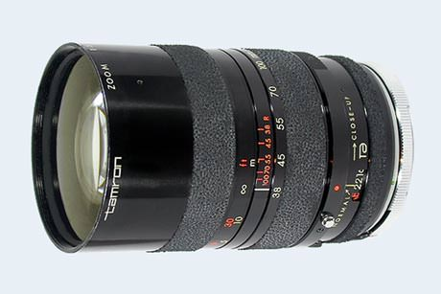 | Tamron 38-100mm f/3.5 (CZ-38M) | Ad1 | CZ-38M | 1976-1978 | 67 | 2.8 x 4.3 in | 25.6 oz | 20-50
Tele-photo zooms |  | Mount  Type  (AD/AD2) | Lens  ID  (#) | Production  Period  (years) | Filter  Type  (size) | Lens  Dimensions  (dia x len) | Lens  Weight  (net) | Ebay  Price  (USD) | Used  Offers  (ebay)
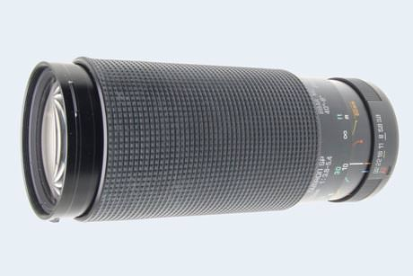 | Tamron SP 60-300mm f/3.8-5.4 | Ad2 | 23A | 1983-2000 | 62 | 2.7 x 6.4 in | 30.7 oz | 20-60
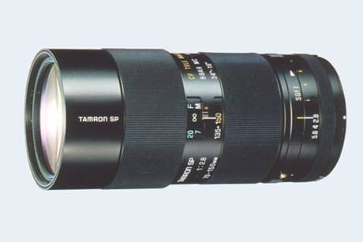 | Tamron SP 70-150mm f/2.8 SOFT | Ad2 | 51A | 1979-1983 | 62 | 2.7 x 5.8 in | 26.8 oz | 250-500
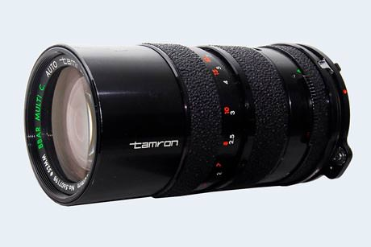 | Tamron 70-150mm f/3.5 (CZ-715) | Ad1 | CZ-150 | 1976-1978 | 52 | 2.6 x 4.6 in | 16.4 oz | 10-40
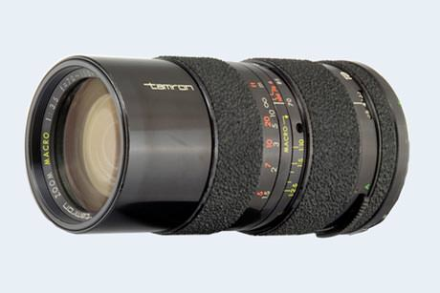 | Tamron 70-150mm f/3.5 (CZ-150) | Ad1 | QZ-150M | 1978-1980 | 52 | 2.6 x 4.9 in | 19.4 oz | 10-40
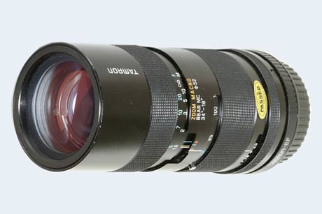 | Tamron 70-150mm f/3.5 (02A) | Ad2 | 02A | 1979-1980 | 52 | 2.6 x 4.9 in | 20.6 oz | 20-40
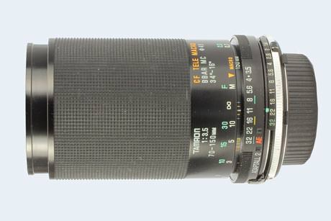 | Tamron 70-150mm f/3.5 (20A) | Ad2 | 20A | 1980-1984 | 49 | 2.6 x 3.9 in | 16.2 oz | 20-40
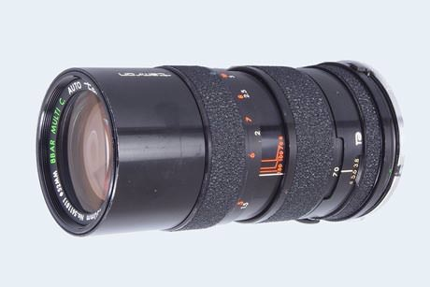 | Tamron 70-150mm f/3.8 | Ad1 | CZ-715 | 1976-1978 | 52 | 2.6 x 4.6 in | 16.4 oz | 20-60
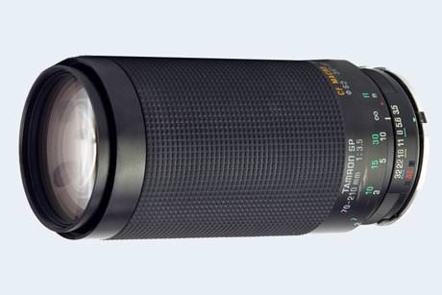 | Tamron SP 70-210mm f/3.5 | Ad2 | 19AH | 1984-1999 | 62 | 2.8 x 5.9 in | 30.3 oz | 30-90
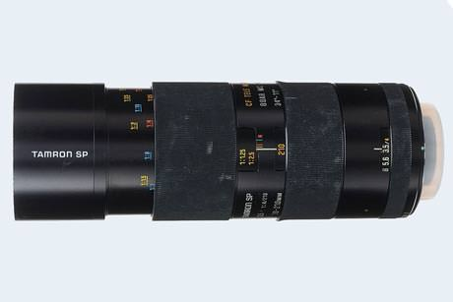 | Tamron SP 70-210mm f/3.5-4 | Ad2 | 52A | 1979-1984 | 58 | 2.6 x 6.5 in | 26.5 oz | 20-80
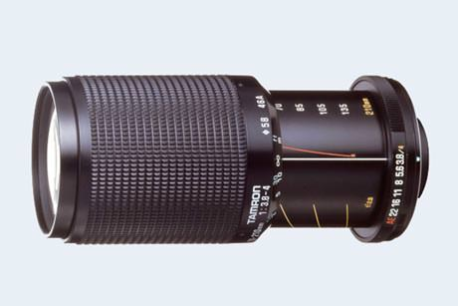 | Tamron 70-210mm f/3.8-4 | Ad2 | 46A | 1986-1988 | 58 | 2.6 x 5.5 in | 20.5 oz | 20-40
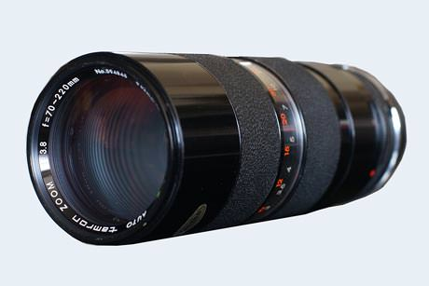 | Tamron 70-220mm f/3.8 | Ad1 | Z-220 | 1973-1976 | 62 | 2.8 x 7.1 in | 37.0 oz | 10-40
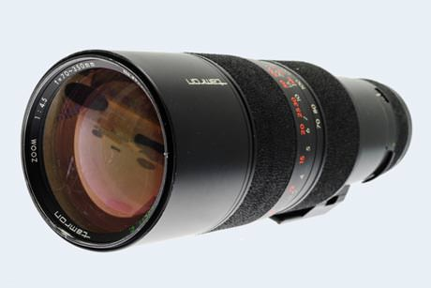 | Tamron 70-350mm f/4.5 | Ad1 | CZ-735 | 1976-1979 | 82 | 3.5 x 10.8 in | 64.2 oz | 40-150
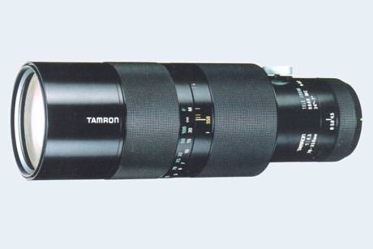 | Tamron 70-350mm f/4.5 | Ad2 | 05A | 1979-1984 | 82 | 3.5 x 10.8 in | 76.5 oz | 50-200
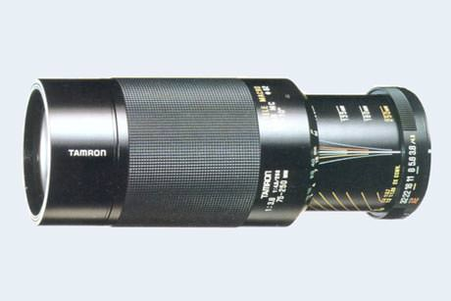 | Tamron 75-250mm f/3.8-4.5 (04A) | Ad2 | 04A | 1979-1982 | 62 | 2.8 x 7.0 in | 30.7 oz | 20-40
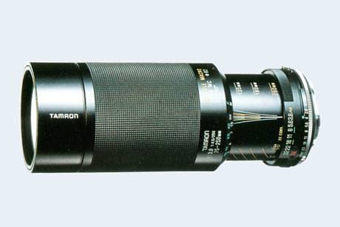 | Tamron 75-250mm f/3.8-4.5 (104A) | Ad2 | 104A | 1981-1984 | 62 | 2.8 x 6.8 in | 30.2 oz | 20-40
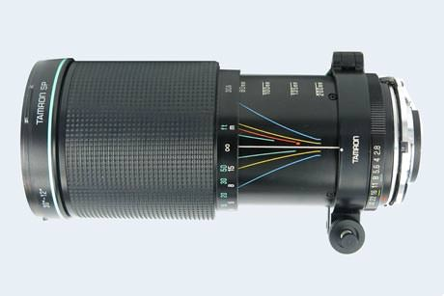 | Tamron SP 80-200mm f/2.8 | Ad2 | 30A | 1985-1992 | 77 | 3.2 x 6.9 in | 47.9 oz | 200-600
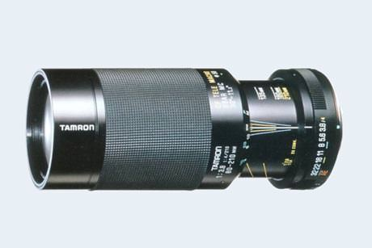 | Tamron 80-210mm f/3.8-4 (03A) | Ad2 | 03A | 1979-1982 | 58 | 2.6 x 5.8 in | 21.5 oz | 20-80
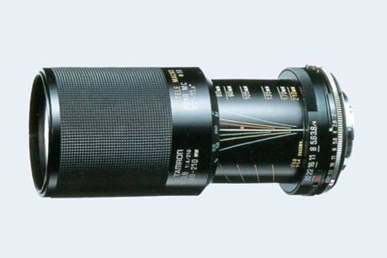 | Tamron 80-210mm f/3.8-4 (103A) | Ad2 | 103A | 1981-1987 | 58 | 2.6 x 5.4 in | 22.4 oz | 20-80
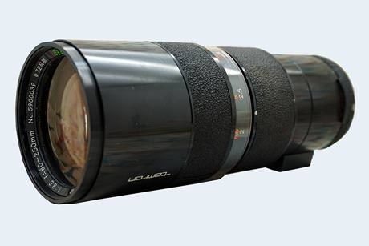 | Tamron 80-250mm f/3.8 | Ad1 | Z-250 | 1973-1976 | 72 | 3.1 x 7.9 in | 45.2 oz | 20-50
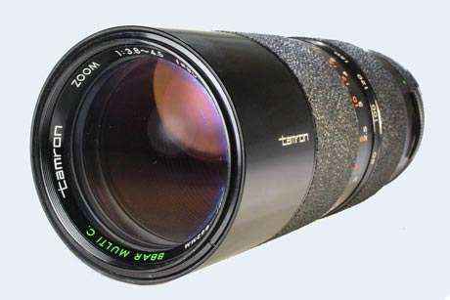 | Tamron 80-250mm f/3.8-4.5 (CZ-825) | Ad1 | CZ-825 | 1976-1978 | 62 | 2.8 x 7.1 in | 33.5 oz | 20-50
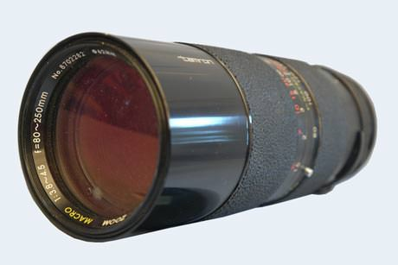 | Tamron 80-250mm f/3.8-4.5 (QZ-250M) | Ad1 | QZ-250M | 1978-1980 | 62 | 2.8 x 7.1 in | 31.0 oz | 20-50
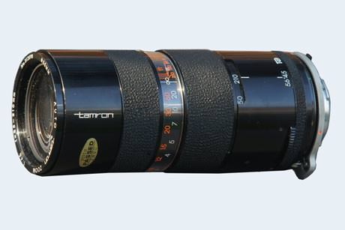 | Tamron 85-210mm f/4.5 (Z-210) | Ad1 | Z-210 | 1973-1976 | 55 | 2.6 x 5.9 in | 23.6 oz | 10-40
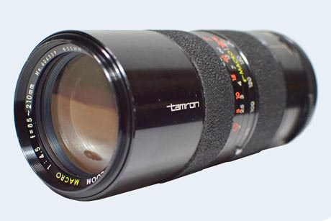 | Tamron 85-210mm f/4.5 (CZ-210M) | Ad1 | CZ-210M | 1976-1978 | 55 | 2.6 x 5.7 in | 22.6 oz | 10-40
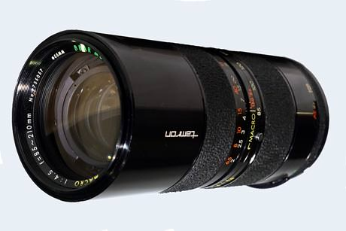 | Tamron 85-210mm f/4.5 (QZ-210M) | Ad1 | QZ-210M | 1978-1980 | 55 | 2.6 x 5.7 in | 22.6 oz | 10-40
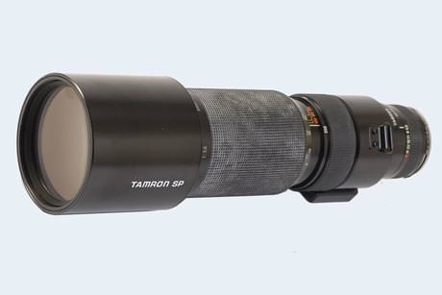 | Tamron SP 200-500mm f/5.6 | Ad2 | 31A | 1984-1992 | 95 | 4.1 x 14.2 in | 96.1 oz | 250-500
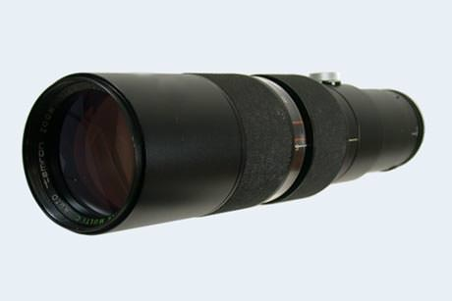 | Tamron 200-500mm f/6.9 (Z-500) | Ad1 | Z-500 | 1974-1976 | 82 | 3.5 x 14.6 in | 96.7 oz | 40-150
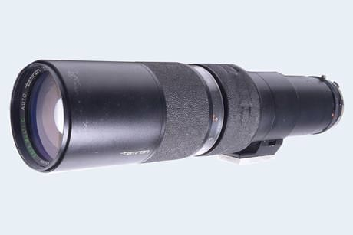 | Tamron 200-500mm f/6.9 (QZ-500) | Ad1 | CZ-500 | 1976-1979 | 82 | 3.5 x 14.6 in | 98.6 oz | 40-150
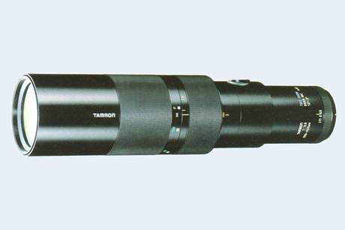 | Tamron 200-500mm f/6.9 | Ad2 | 06A | 1979-1984 | 82 | 3.5 x 14.6 in | 97.7 oz | 50-200
Tele-photo primes |  | Mount  Type  (AD/AD2) | Lens  ID  (#) | Production  Period  (years) | Filter  Type  (size) | Lens  Dimensions  (dia x len) | Lens  Weight  (net) | Ebay  Price  (USD) | Used  Offers  (ebay)
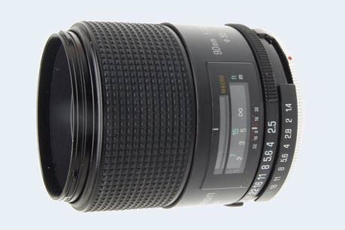 | Tamron SP 90mm f/2.5 | Ad2 | 52B | 1979-1988 | 49 | 2.6 x 2.6 in | 14.8 oz | 50-200
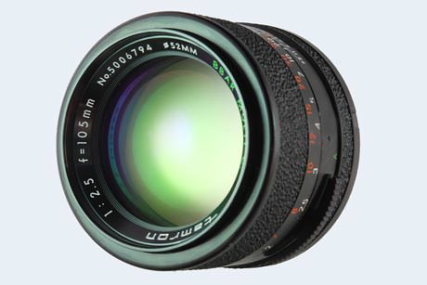 | Tamron 105mm f/2.5 | Ad1 | CT-105 | 1976-1979 | 52 | 2.6 x 2.0 in | 9.7 oz | 50-100
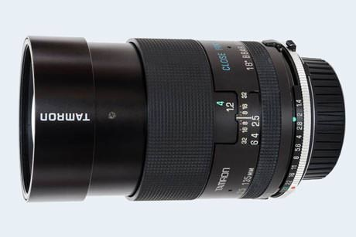 | Tamron 135mm f/2.5 | Ad2 | 03B | 1979-1984 | 58 | 2.6 x 3.1 in | 14.5 oz | 20-80
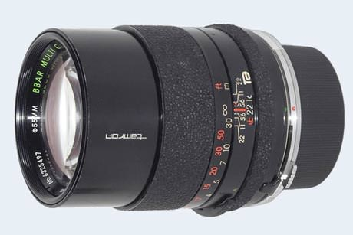 | Tamron 135mm f/2.8 | Ad1 | CT-135 | 1976-1979 | 55 | 2.6 x 3.0 in | 13.2 oz | 30-80
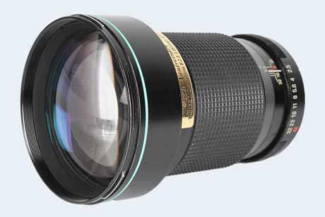 | Tamron SP 180mm f/2.5 LD-IF | Ad2 | 63B | 1988-1992 | 77 | 3.2 x 4.7 in | 28.2 oz | 300-500
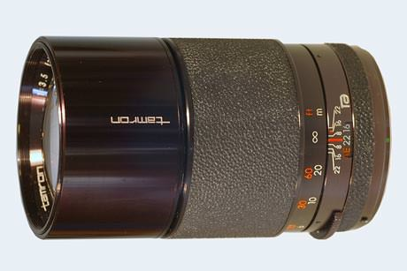 | Tamron 200mm f/3.5 | Ad1 | CT-200 | 1976-1979 | 62 | 2.7 x 4.5 in | 18.3 oz | 40-90
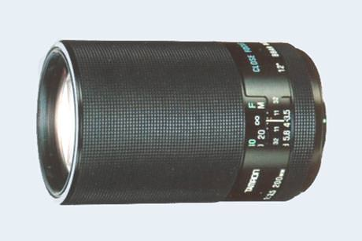 | Tamron 200mm f/3.5 | Ad2 | 04B | 1979-1984 | 58 | 2.7 x 4.3 in | 19.0 oz | 40-80
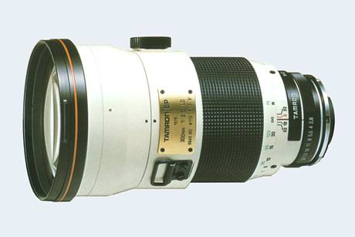 | Tamron SP 300mm f/2.8 LD | Ad2 | 107B | 1983-1984 | 112 | 4.6 x 7.8 in | 73.1 oz | 500-1000
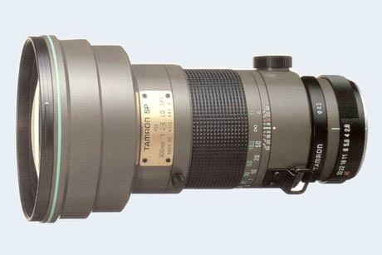 | Tamron SP 300mm f/2.8 LD-IF (60B) | Ad2 | 60B | 1984-1992 | 112 | 4.6 x 8.3 in | 73.9 oz | 500-1000
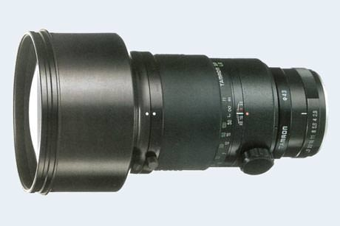 | Tamron SP 300mm f/2.8 LD-IF (360B) | Ad2 | 360B | 1993-2006 | 112 | 4.6 x 8.2 in | 80.0 oz | 500-1000
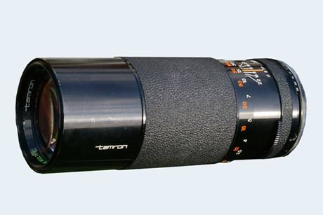 | Tamron 300mm f/5.6 | Ad1 | CT-300 | 1976-1979 | 58 | 2.6 x 6.3 in | 20.5 oz | 20-80
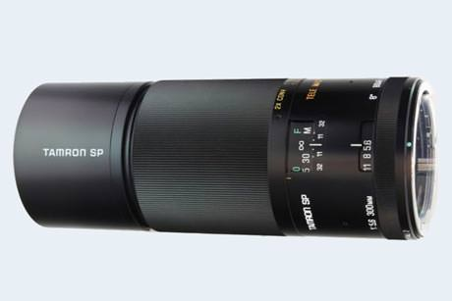 | Tamron SP 300mm f/5.6 | Ad2 | 54B | 1979-1984 | 58 | 2.6 x 6.5 in | 21.5 oz | 20-80
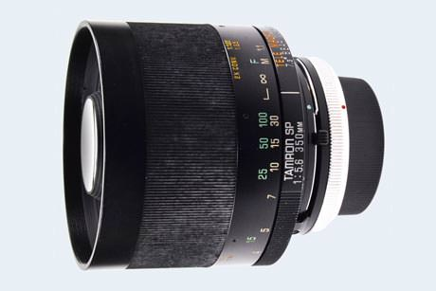 | Tamron SP 350mm f/5.6 | Ad2 | 06B | 1981-1985 | 82 | 3.4 x 3.0 in | 20.4 oz | 250-500
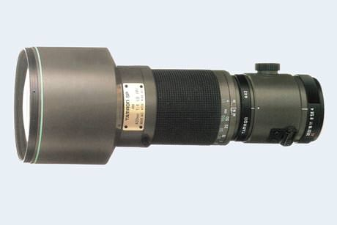 | Tamron SP 400mm f/4 LD-IF | Ad2 | 65B | 1988-1995 | 112 | 4.6 x 11.5 in | 80.1 oz | 400-800
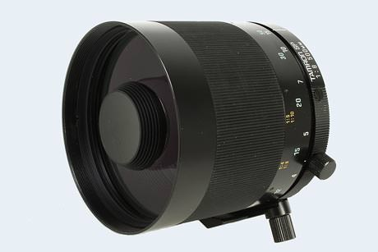 | Tamron SP 500mm f/8 (55B) | Ad2 | 55B | 1979-1983 | 82 | 3.3 x 3.4 in | 20.3 oz | 50-200
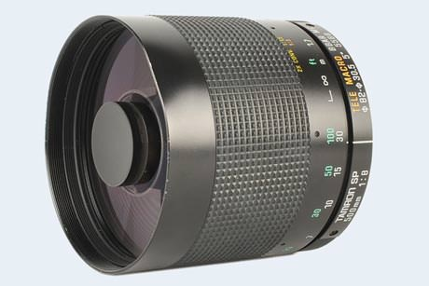 | Tamron SP 500mm f/8 (55BB) | Ad2 | 55BB | 1983-2006 | 82 | 3.3 x 3.4 in | 21.0 oz | 50-200

Tamron Adaptall FAQ
In order to mount or unmount an Adaptall Custom fitting, it is necessary to open the lens to maximum aperture. Then, during mounting, one aligns the green dots, puts the extending tabs into corresponding slots on the aperture ring, and turns the adapter clockwise. To unlock, one presses the silver release lever, holds the lens firmly, and turns the adapter counterclockwise. – Below is some further information on some additional aspects of the lens system.
Is the Tamron Adapt-A-Matic mount identical to the Adaptall mount?
No, Adapt-A-Matic mounts are not the same as Adaptall. Adapt-A-Matic is a threaded, interchangeable mount system that Tamron developed in 1968, and that was replaced by the Adaptall bayonet system. The Adapt-A-Matic mount attaches to the lens with a lock ring with internal 58mm threads.
What advantages did the Adaptall mount offer over the previous Adapt-A-Matic?
While the earlier Adapt-A-Matic lens mount also offered automatic diaphragm operation, it was more cumbersome to operate and diaphragm coupling not always reliable. The photographer had to mate a longish coupling pin with an internal lens auto-diaphragm rod. Also, the lens mount adapter itself consisted of two pieces which had to be attached carefully in order for the system to work properly.
Can I use an Adaptall-2 mount to attach a mid-1970s Adaptall ("without-2") lens to my camera?
Yes, Adaptall-2 mount adapters are backward compatible and will fit Adaptall lenses also. Indeed, the newer version is considered to be more solid and reliable.
What is the flange-focal distance for Adaptall and Adaptall-2 lenses?
The flange-focal distance for all of Tamron's interchangeable bayonet mount lenses (including Adapt-A-Matic) is 50.7mm.
Can Tamron Adaptall lenses be used on Canon EOS cameras?
Canon radically changed its lens attachment system in the mid-1980s when switching from the FD to the EF/EOS mount. Original Adaptall customs mounts are available for the FD mount, but not for the EF/EOS mount. However, there are adapters to use Nikon or Olympus lenses, which have a relatively long flange to focal distance, on EOS cameras. Hence, an Adaptall lens in combination with the Nikon or Olymus custom mount and a Nikon/EOS or Olympus/EOS adapter could be attached to an EOS camera. Alternatively, there are third party solutions for adapters that directly link the EOS camera and the Adaptall lens. In any case, there is no aperture coupling and the Tamron lens will have to be used via stop-down metering.
Do Adaptall lenses fit Nikon digital cameras?
Nikon provides good backward compatibility, so that legacy Adaptall lenses in Nikon custom mount can often be used on modern cameras. However, some limitations apply. In particular, legacy F-mount lenses can be mounted on all cameras, but only the higher end Nikon bodies will meter with them (with other Nikon bodies, the lenses have to be used in stop-down mode). See the FAQ section of the Nikon lens compendium or this dpreview article for information on particular camera-lens combinations.
Is it possible to use Adaptall 2 lenses on Sony E-mount cameras?
Yes, while the E-mount is new and Tamron never produced an Adaptall custom mount for it, third party vendors, such as Fotodiox, provide these adapters for mirrorless camera systems. There is no aperture coupling or autofocus, though.

Did Tamron release an Adaptall mount for Leica's R-system?
Yes, there are indeed two Adaptall custom mounts for Leica R. One that could be used with the Leicaflex SL/SL2 and one that fitted the Leica R4, R4s, R5, R-E, R6, R6.2, R7, R8 and R9. The mounts provided automatic diaphragm and full aperture metering. All exposure modes of the listed cameras were supported, except for the R8/R9 where only the "m" and "A" modes worked properly.
Are there any notable differences between Adaptall Customs mounts for different camera systems?
Yes, there are some differences in design and operation. Marcus Brown discusses the issue in detail at tremyfoel.co.uk. Also, Tamron included a notice with its custom mounts that explained a number of limitations and particularities. Matt Denton has put a nice summary of these notices together at mattsclassiccameras.com.
Are there any special edition lenses in the Adaptall line?
Yes, the Tamron Adaptall-2 180mm f/2.5 LD (IF) was released to commemorate the company's 35th anniversary and carried a corresponding plate on the lens barrel.
What does the acronym BBAR stand for?
BBAR is an abbreviation for Broad Band Anti Reflection, the multi-coating Tamron used on its lenses.
Which is the best Tamron Adaptall 2 lens?
The SP "Super Performance" line of Adaptall-2 lenses offers very good imaging performance and the LD lenses within this series satisfy professional requirements. However, other lenses in the lineup might provide an even better cost-benefit ratio, so that the answer to the question which Adaptall lens is best depends very much on ones imaging needs and financial budget.

Further Reading
A collection of test reports on different Adaptall lenses is available at adaptall-2.com. Moreover, if you are looking for bargains among third party legacy lenses, you might also want to check out the compendiums of Soligor and Vivitar lenses. If however you are willing to spend a little more, you might well be interested in the Leica R-lens catalog or the CONTAX Carl Zeiss catalog, which contain some truly exceptional optics that can be adapted to and used with a variety of camera mounts.

